My God, and is thy table spread AMNS 259 Melody: Rockingham L.M.
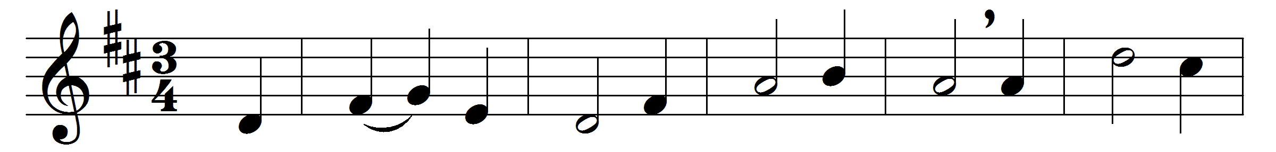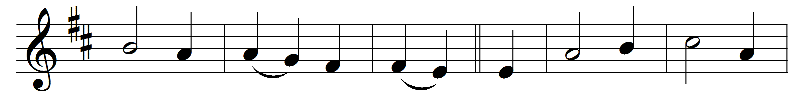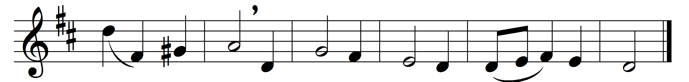

My God, and is thy table spread,
and doth thy cup with love o’erflow?
thither be all thy children led,
and let them all thy sweetness know.

Hail, sacred feast which Jesus makes,
rich banquet of his flesh and blood!
thrice happy he who here partakes
that sacred stream, that heavenly food.

Why are its bounties all in vain
before unwilling hearts displayed?
was not for them the Victim slain?
are they forbid the children’s bread?

O let thy table honoured be,
and furnished well with joyful guests;
and may each soul salvation see,
that here its sacred pledges tastes.

Words: Philip Doddridge (1702-1751)
Music: Adapted by Edward Miller (1730-1807)

