Author of life divine AMNS 258 Melody: Gweedore 6 6. 6 6. 8 8.
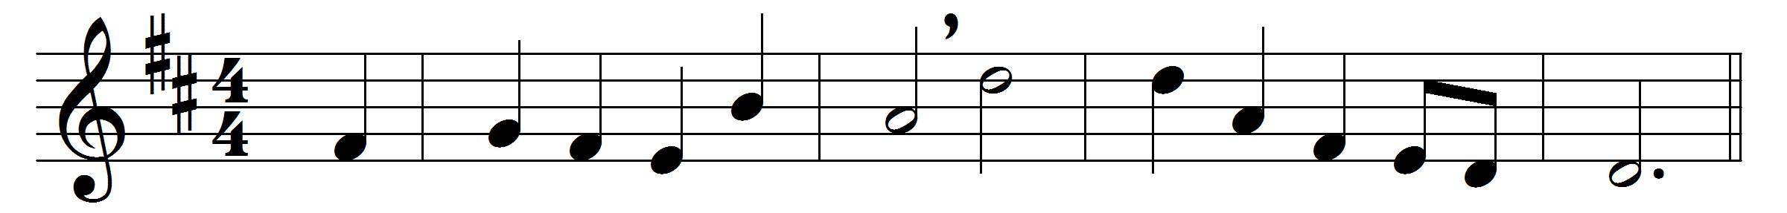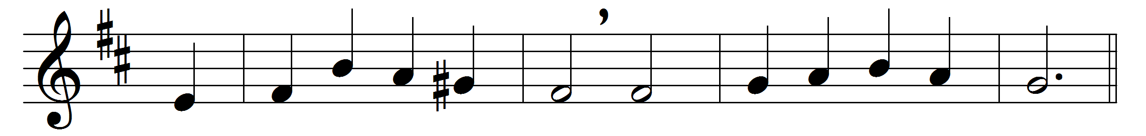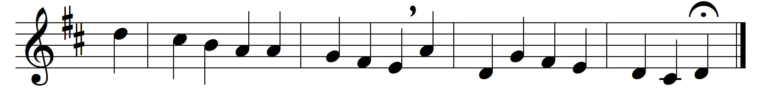

Author of life divine
who hast a table spread,
furnished with mystic wine
and everlasting bread,
preserve the life thyself hast given,
and feed and train us up for heaven.
Our needy souls sustain
with fresh supplies of love,
till all thy life we gain,
and all thy fulness prove,
and, strengthened by thy perfect grace,
behold without a veil thy face.

Words: Charles Wesley (1707-1788)
Music: Samuel Sebastian Wesley (1810-1876)

