Thee we adore, O hidden Saviour, thee AMNS 254 Melody: Adoro te devote 10 10. 10 10.
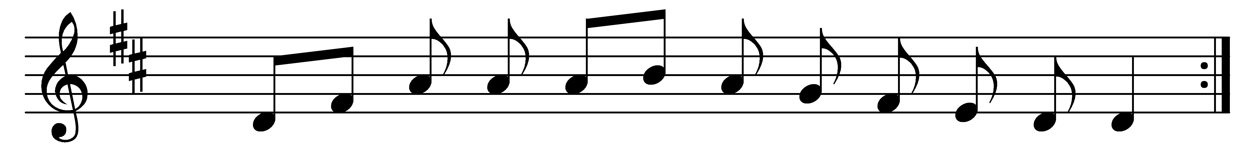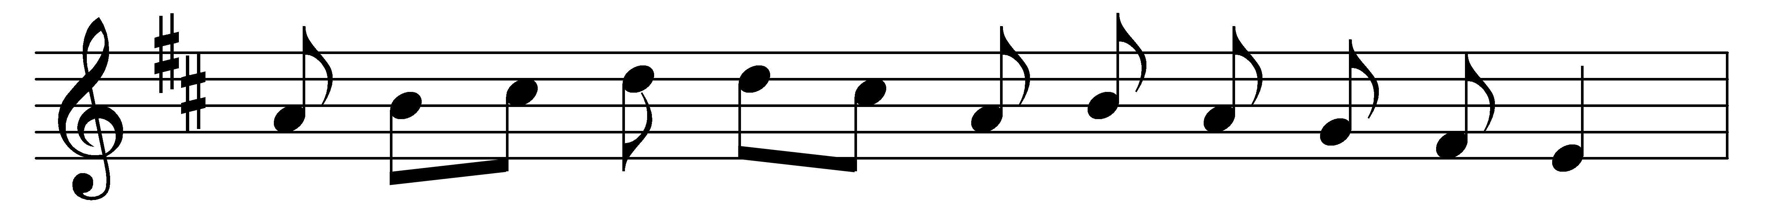
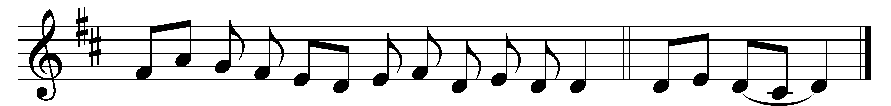

Thee we adore, O hidden Saviour, thee,
who in thy sacrament dost deign to be;
both flesh and spirit at thy presence fail,
yet here thy presence we devoutly hail.

O blest memorial of our dying Lord,
who living bread to men doth here afford;
O may our souls for ever feed on thee,
and thou, O Christ, for ever precious be.

Fountain of goodness, Jesu, Lord and God,
cleanse us, unclean, with thy most cleansing blood;
increase our faith and love, that we may know
the hope and peace which from thy presence flow.

O Christ, whom now beneath a veil we see,
may what we thirst for soon our portion be:
to gaze on thee unveiled, and see thy face,
the vision of thy glory and thy grace. Amen.

Words: St. Thomas Aquinas (1227-1274), translated by James Russell Woodford (1820-1885)
Music: Mode v

