Now, my tongue, the mystery telling AMNS 252 Melody: Pange lingua 8 7. 8 7. 8 7.
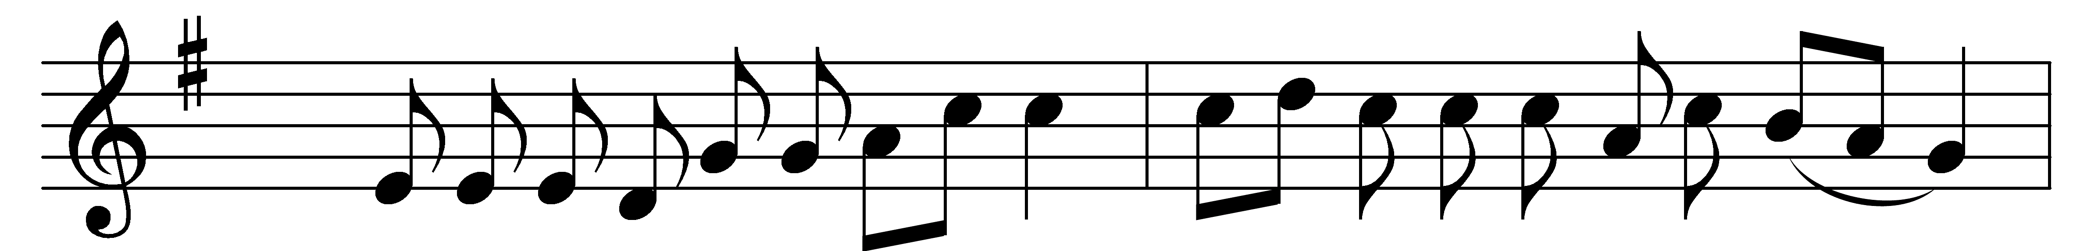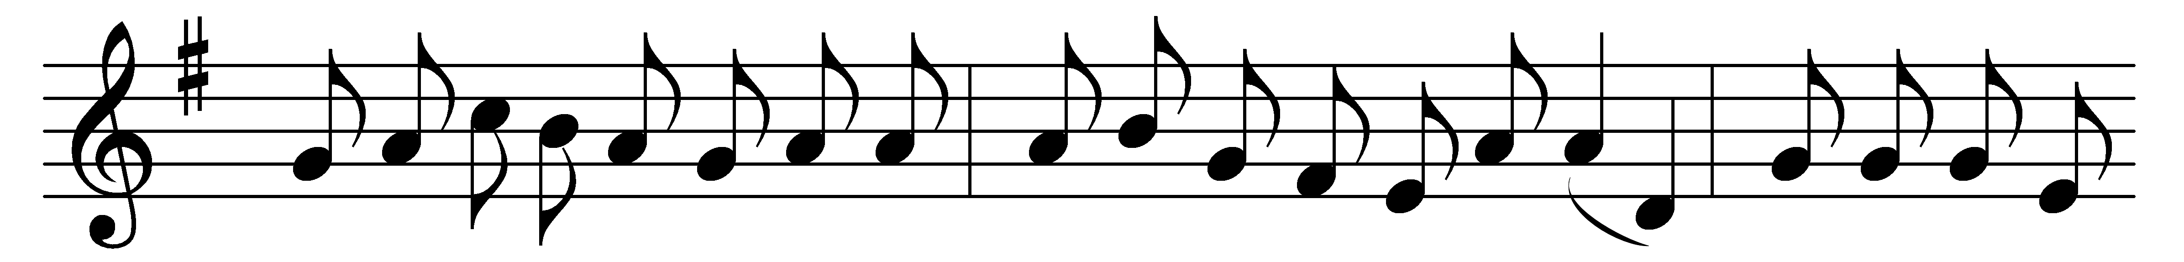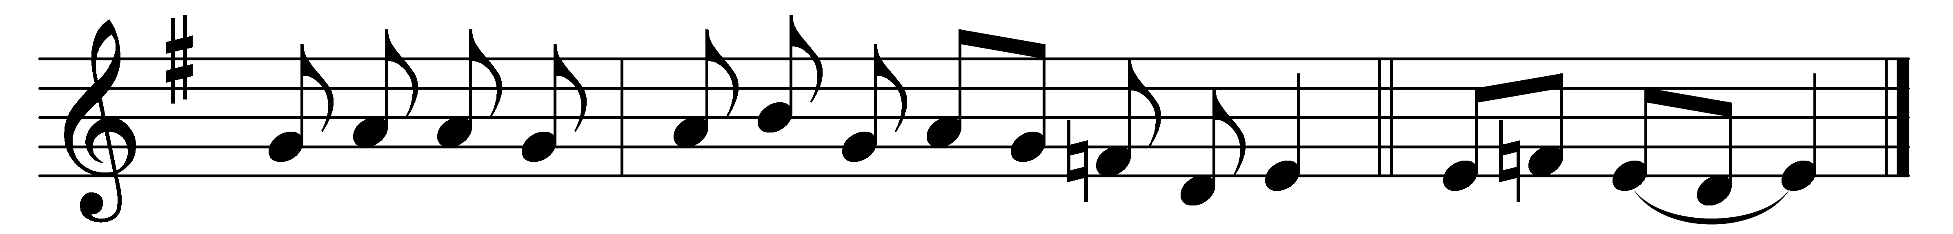

Part 1

Now, my tongue, the mystery telling
of the glorious body sing,
and the blood, all price excelling,
which the Gentiles’ Lord and King,
in a Virgin’s womb once dwelling,
shed for this world’s ransoming.

Given for us, and condescending
to be born for us below,
he, with men in converse blending,
dwelt the seed of truth to sow,
till he closed with wondrous ending
his most patient life of woe.

That last night, at supper lying,
’mid the Twelve, his chosen band,
Jesus, with the law complying,
keeps the feast its rites demand;
then, more precious food supplying,
gives himself with his own hand.

Word-made-flesh, true bread he maketh
by his word his flesh to be,
wine his blood; which whoso taketh
must from carnal thoughts be free:
faith alone, though sight forsaketh,
shows true hearts the mystery.

Part 2

Therefore we, before him bending,
this great sacrament revere:
types and shadows have their ending,
for the newer rite is here;
faith, our outward sense befriending,
makes our inward vision clear.

Glory let us give and blessing
to the Father and the Son,
honour, might, and praise addressing,
while eternal ages run;
ever too his love confessing,
who, from both, with both is one. Amen.

Words: St. Thomas Aquinas (1227-1274), translated by John Mason Neale (1818-1866), Edward Caswall (1814-1878), and others
Music: Mode iii

