Hark, a thrilling voice is sounding AMNS 24 Melody: Merton 8 7. 8 7.
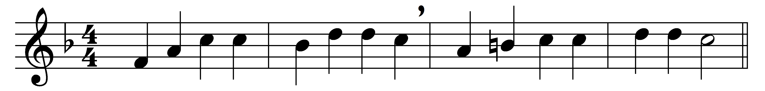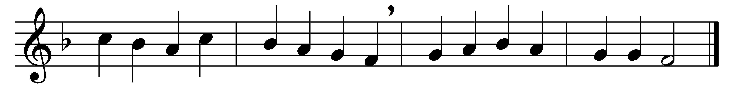

Hark, a thrilling voice is sounding;
‘Christ is nigh,’ it seems to say;
‘cast away the dreams of darkness,
O ye children of the day.’

Wakened by the solemn warning,
let the earth-bound soul arise;
Christ, her Sun, all ill dispelling,
shines upon the morning skies.

Lo, the Lamb, so long expected,
comes with pardon down from heaven;
let us haste, with tears of sorrow,
one and all to be forgiven;

that when next he comes with glory,
and the world is wrapped in fear,
with his mercy he may shield us,
and with words of love draw near.

Honour, glory, might, and blessing
to the Father and the Son,
with the everlasting Spirit,
while eternal ages run.

Words: Latin, translated by Edward Caswall (1814-1878)
Music: William Henry Monk (1823-1889)

