O my Saviour, lifted AMNS 248 Melody: North Coates 6 5. 6 5.
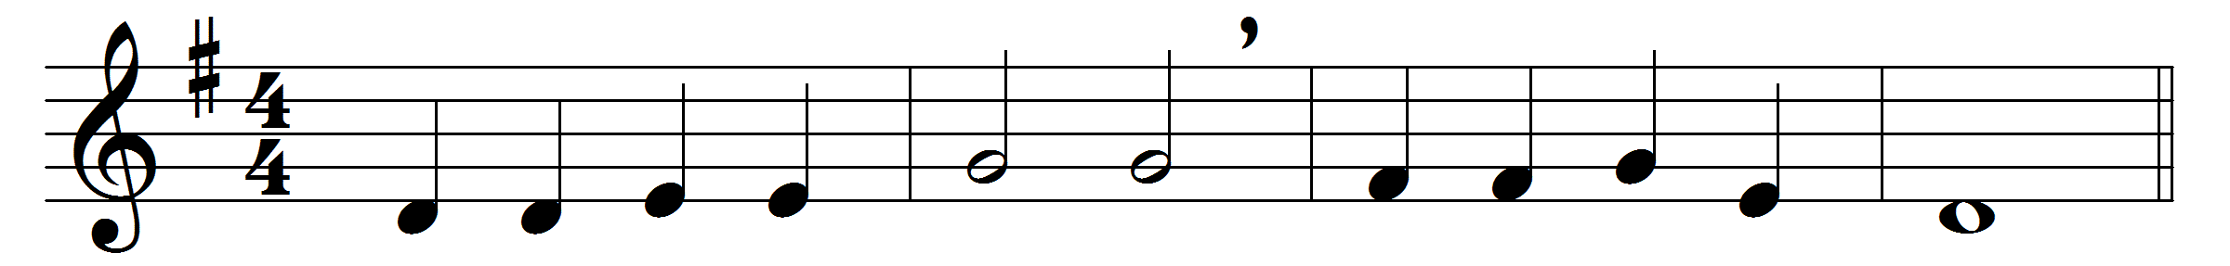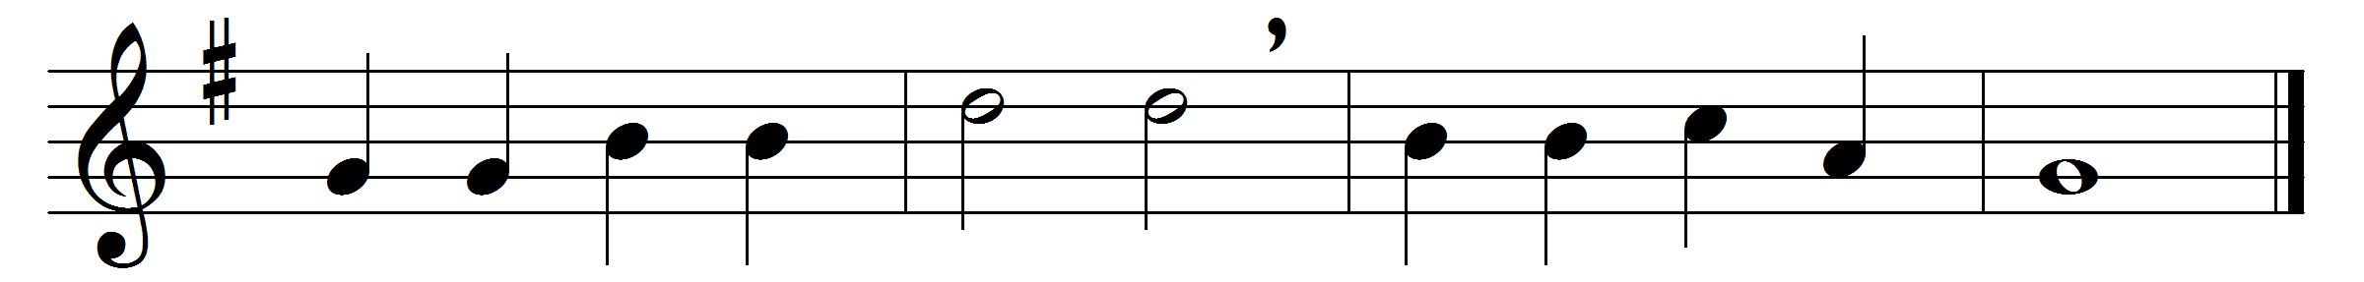

O my Saviour, lifted
from the earth for me,
draw me, in thy mercy,
nearer unto thee.
Lift my earth-bound longings,
fix them, Lord, above;
draw me with the magnet
of thy mighty love.
Lord, thine arms are stretching
ever far and wide,
to enfold thy children
to thy loving side.
And I come, O Jesus:
dare I turn away?
No, thy love hath conquered,
and I come to-day,
bringing all my burdens,
sorrow, sin, and care;
at thy feet I lay them,
and I leave them there.

Words: William Walsham How (1823-1897)
Music: Timothy Richard Matthews (1826-1910)

