Jesus, these eyes have never seen AMNS 245 Melody: Nun danket all C.M.
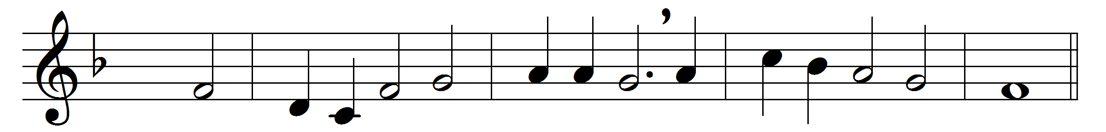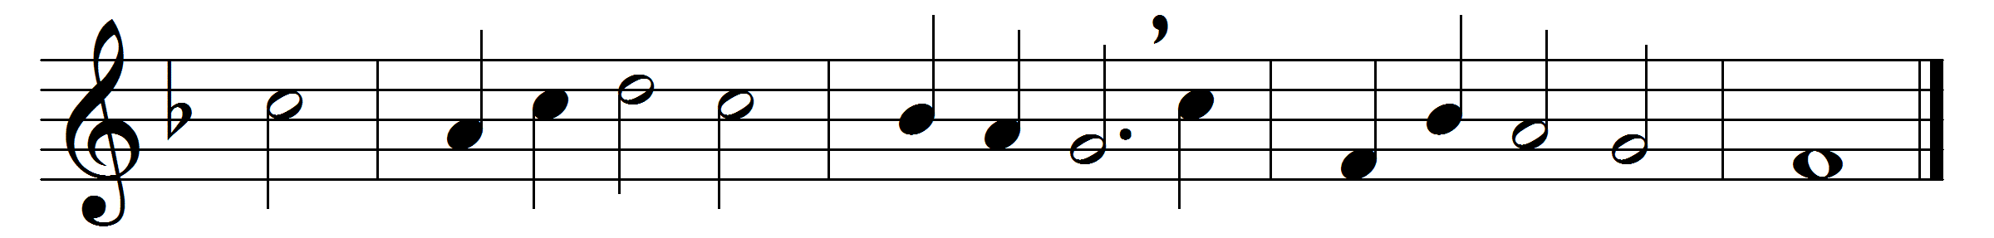

Jesus, these eyes have never seen
that radiant form of thine;
the veil of sense hangs dark between
thy blessèd face and mine.
I see thee not, I hear thee not,
yet art thou oft with me;
and earth hath ne’er so dear a spot
as where I meet with thee.
Yet, though I have not seen, and still
must rest in faith alone,
I love thee, dearest Lord, and will,
unseen, but not unknown.
When death these mortal eyes shall seal,
and still this throbbing heart,
the rending veil shall thee reveal
all glorious as thou art.

Words: Ray Palmer (1808-1887)
Music: Melody from Praxis Pietatis, 1647

