Lord, it belongs not to my care AMNS 242 Melody: St. Hugh C.M.
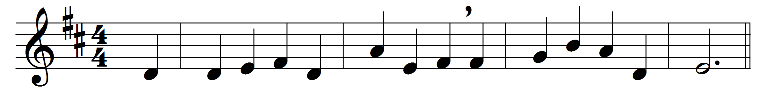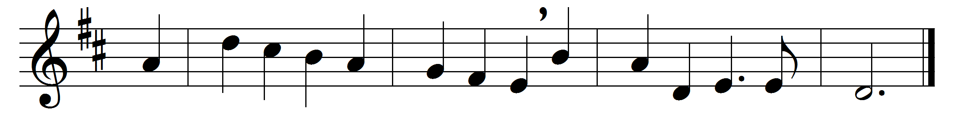

Lord, it belongs not to my care
whether I die or live:
to love and serve thee is my share,
and this thy grace must give.

Christ leads me through no darker rooms
than he went through before;
he that unto God’s kingdom comes
must enter by this door.

Come, Lord, when grace hath made me meet
thy blessèd face to see;
for if thy work on earth be sweet,
what will thy glory be!

Then I shall end my sad complaints
and weary, sinful days,
and join with the triumphant saints
that sing my Saviour’s praise.

My knowledge of that life is small,
the eye of faith is dim;
but ’tis enough that Christ knows all,
and I shall be with him.

Words: Richard Baxter (1615-1691)
Music: Edward John Hopkins (1818-1901)

