‘Lift up your hearts!’ We lift them, Lord, to thee AMNS 241 Melody: Woodlands 10 10. 10 10.
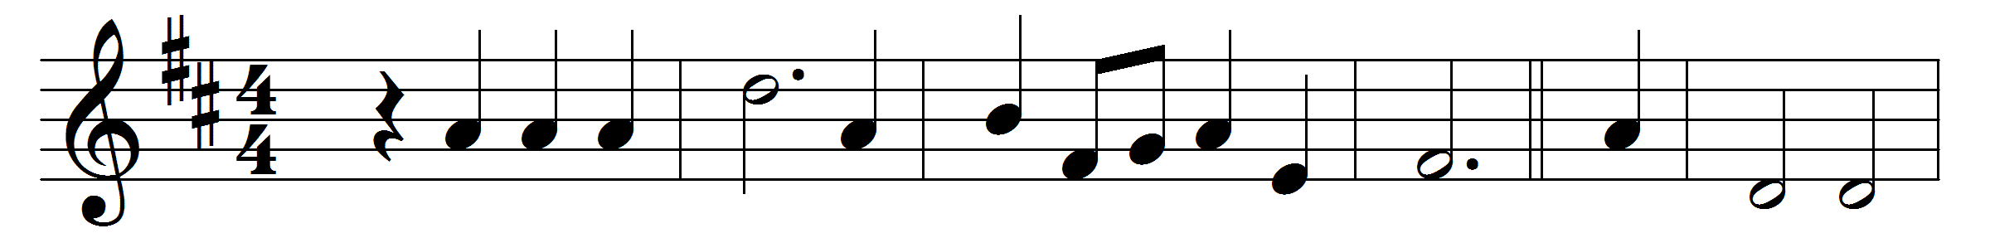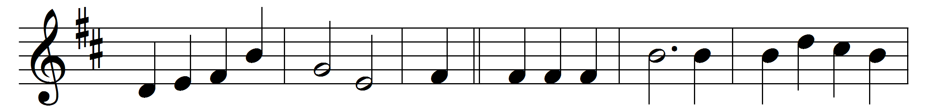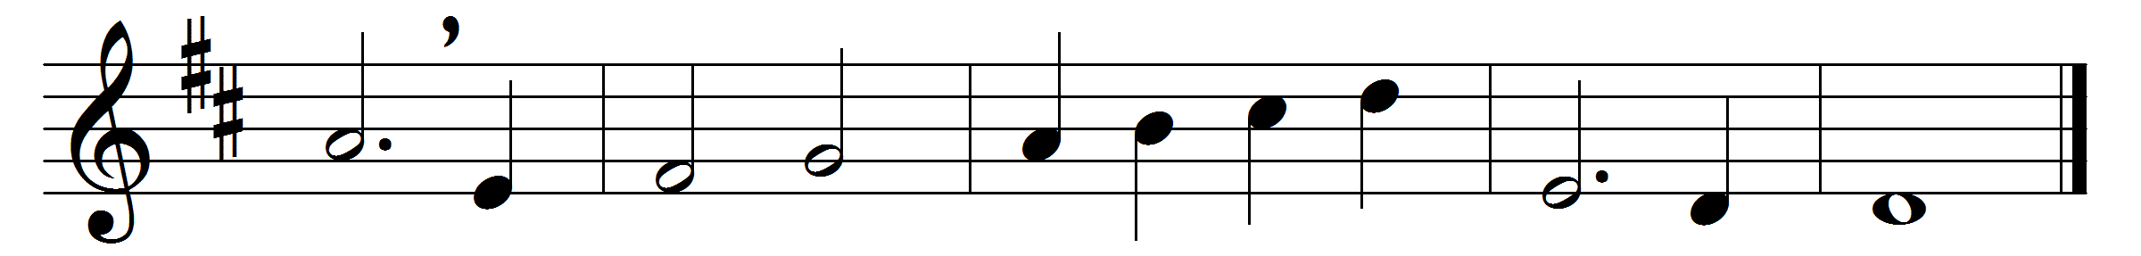

‘Lift up your hearts!’ We lift them, Lord, to thee;
here at thy feet none other may we see:
‘Lift up your hearts!’ E’en so, with one accord,
we lift them up, we lift them to the Lord.

Above the level of the former years,
the mire of sin, the slough of guilty fears,
the mist of doubt, the blight of love’s decay,
O Lord of light, lift all our hearts to-day.

Above the swamps of subterfuge and shame,
the deeds, the thoughts, that honour may not name,
the halting tongue that dares not tell the whole,
O Lord of truth, lift every Christian soul.

Lift every gift that thou thyself hast given:
low lies the best till lifted up to heaven;
low lie the bounding heart, the teeming brain,
till, sent from God, they mount to God again.

Then, as the trumpet-call in after years,
‘Lift up your hearts!’ rings pealing in our ears,
still shall those hearts respond with full accord,
‘We lift them up, we lift them to the Lord.’

Words: Henry Montagu Butler (1833-1918)
Music: Walter Greatorex (1877-1949)

