Creator of the starry height AMNS 23 Melody: Brockham L.M.
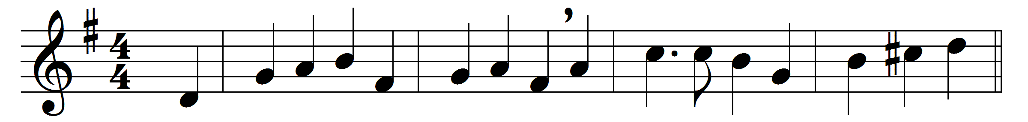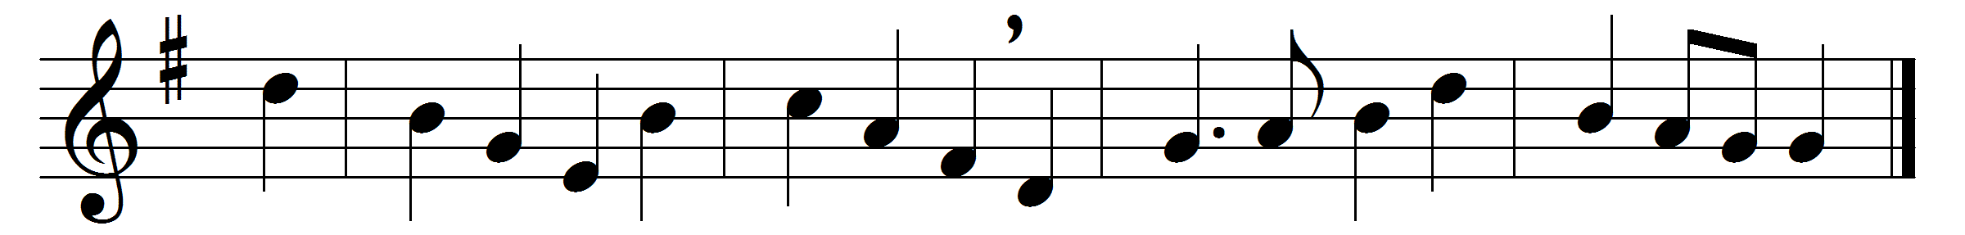

Creator of the starry height,
thy people’s everlasting light,
Jesu, redeemer of us all,
hear thou thy servants when they call.
Thou, sorrowing at the helpless cry
of all creation doomed to die,
didst come to save our fallen race
by healing gifts of heavenly grace.
When earth was near its evening hour,
thou didst, in love’s redeeming power,
like bridegroom from his chamber, come
forth from a Virgin-mother’s womb.
At thy great name, exalted now,
all knees in lowly homage bow;
all things in heaven and earth adore,
and own thee King for evermore.
To thee, O Holy One, we pray,
our judge in that tremendous day,
ward off, while yet we dwell below,
the weapons of our crafty foe.
To God the Father, God the Son,
and God the Spirit, Three in One,
praise, honour, might, and glory be
from age to age eternally.

Words: Latin, translated by John Mason Neale (1818-1866)
Music: Jeremiah Clarke (c. 1673-1707)

