Forth in thy name, O Lord, I go AMNS 239 Melody: Song 34 L.M.
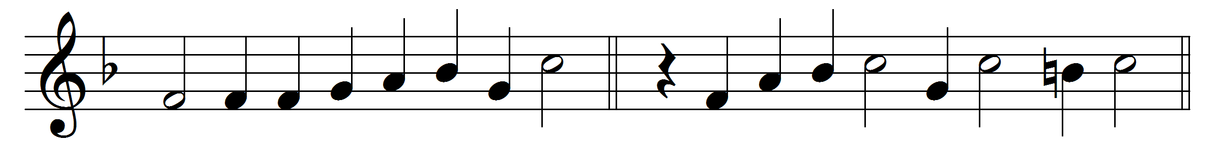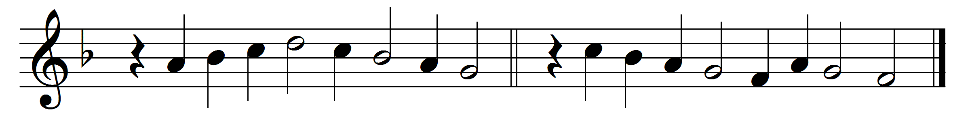

Forth in thy name, O Lord, I go,
my daily labour to pursue;
thee, only thee, resolved to know,
in all I think or speak or do.

The task thy wisdom hath assigned
O let me cheerfully fulfil;
in all my works thy presence find,
and prove thy good and perfect will.

Thee may I set at my right hand,
whose eyes my inmost substance see
and labour on at thy command,
and offer all my works to thee.

Give me to bear thy easy yoke,
and every moment watch and pray,
and still to things eternal look,
and hasten to thy glorious day;

for thee delightfully employ
whate’er thy bounteous grace hath given,
and run my course with even joy,
and closely walk with thee to heaven.

Words: Charles Wesley (1707-1788)
Music: Melody and bass by Orlando Gibbons (1583-1625)

