O Jesus, I have promised AMNS 235 Melody: Wolvercote 7 6. 7 6. D.
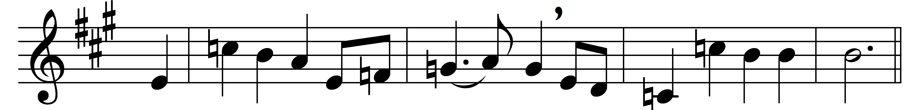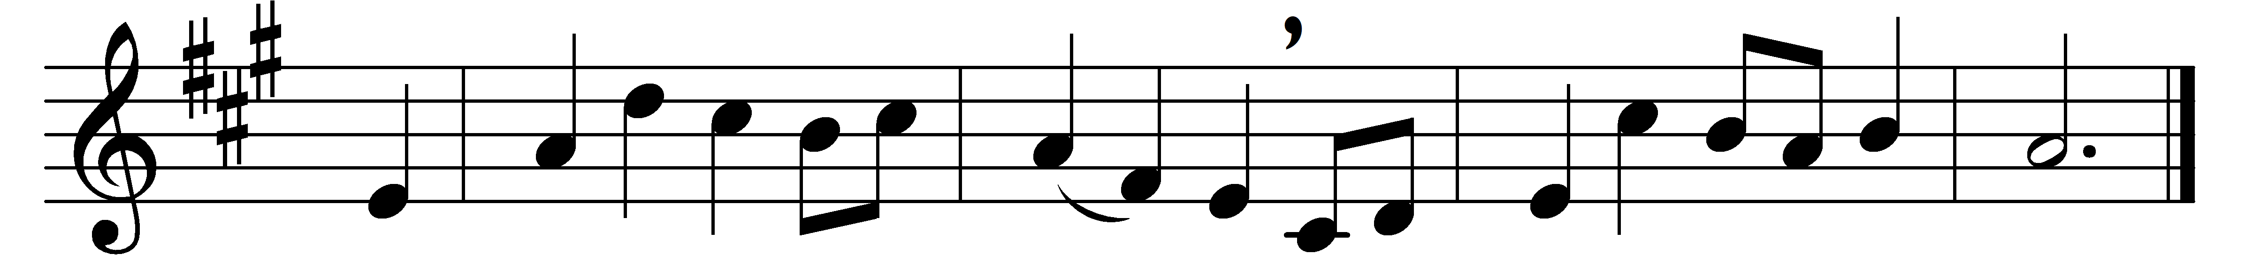
O Jesus, I have promised
to serve thee to the end;
be thou for ever near me,
my Master and my Friend:
I shall not fear the battle
if thou art by my side,
nor wander from the pathway
if thou wilt be my guide.

O let me feel thee near me:
the world is ever near;
I see the sights that dazzle,
the tempting sounds I hear;
my foes are ever near me,
around me and within;
but, Jesus, draw thou nearer,
and shield my soul from sin.

O let me hear thee speaking
in accents clear and still,
above the storms of passion,
the murmurs of self-will;
O speak to reassure me,
to hasten or control;
O speak, and make me listen,
thou guardian of my soul.

O Jesus, thou hast promised
to all who follow thee,
that where thou art in glory
there shall thy servant be;
and, Jesus, I have promised
to serve thee to the end:
O give me grace to follow,
my Master and my Friend.

O let me see thy foot-marks,
and in them plant mine own;
my hope to follow duly
is in thy strength alone:
O guide me, call me, draw me,
uphold me to the end;
and then in heaven receive me,
my Saviour and my Friend.

Words: John Ernest Bode (1816-1874)
Music: William Harold Ferguson (1874-1950)

