O thou who camest from above AMNS 233 Melody: Hereford L.M.
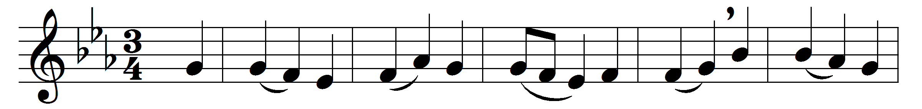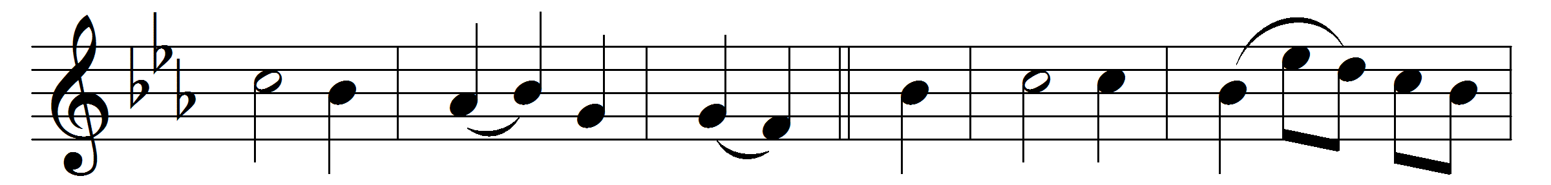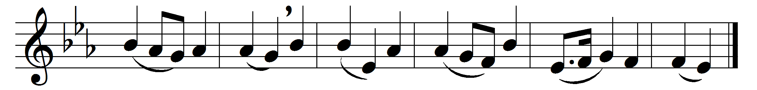

O thou who camest from above
the fire celestial to impart,
kindle a flame of sacred love
on the mean altar of my heart.

There let it for thy glory burn
with inextinguishable blaze,
and trembling to its source return
in humble prayer and fervent praise.

Jesus, confirm my heart’s desire
to work and speak and think for thee;
still let me guard the holy fire
and still stir up the gift in me.

Still let me prove thy perfect will,
my acts of faith and love repeat;
till death thy endless mercies seal,
and make the sacrifice complete.

Words: Charles Wesley (1707-1788)
Music: Samuel Sebastian Wesley (1810-1876)

