Lord, be thy word my rule AMNS 232 Melody: Quam Dilecta 6 6. 6 6.

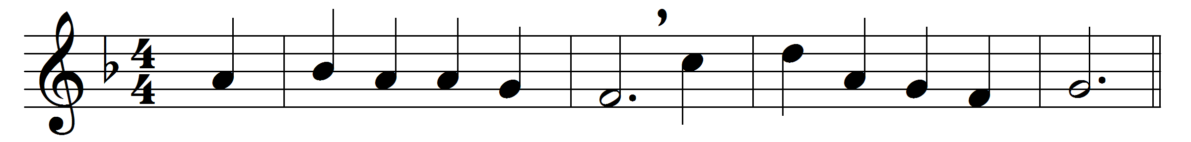
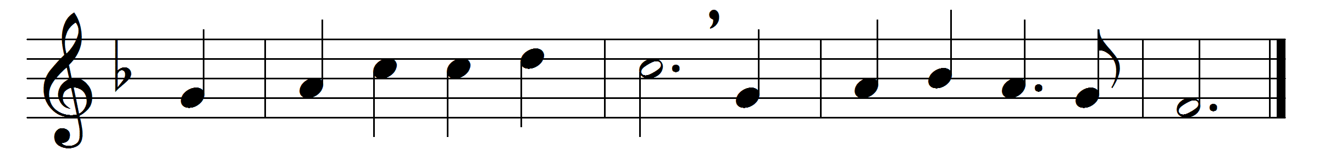

Lord, be thy word my rule,
in it may I rejoice;
thy glory be my aim,
thy holy will my choice;

thy promises my hope,
thy providence my guard,
thine arm my strong support,
thyself my great reward.

Words: Christopher Wordsworth (1807-1885)
Music: Henry Lascelles Jenner (1820-1898)

