This is the day the Lord hath made AMNS 22 Melody: Bishopthorpe C.M.
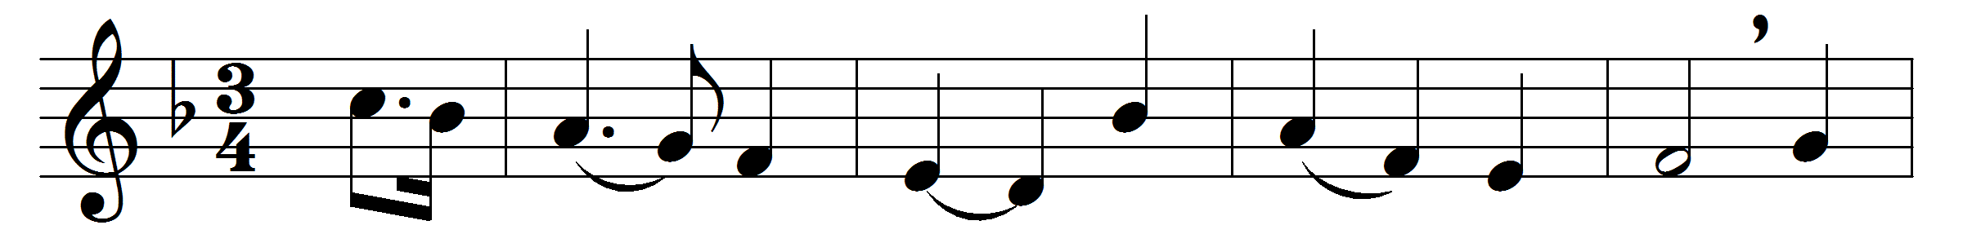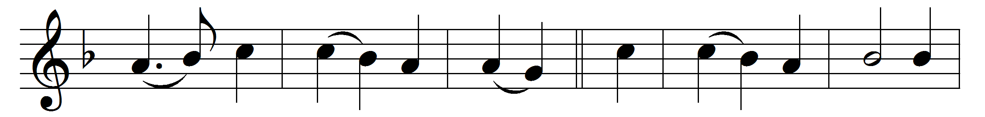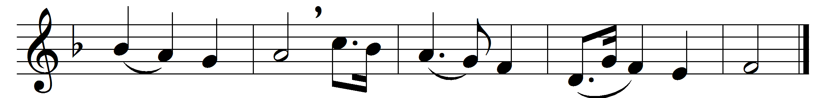

This is the day the Lord hath made,
he calls the hours his own;
let heaven rejoice, let earth be glad,
and praise surround the throne.
To-day he rose and left the dead,
and Satan’s empire fell;
to-day the saints his triumphs spread,
and all his wonders tell.
Hosanna to the anointed King,
to David’s holy Son.
O help us, Lord, descend and bring
salvation from thy throne.
Blest be the Lord, who comes to men
with messages of grace;
who comes, in God his Father’s name,
to save our sinful race.
Hosanna in the highest strains
the Church on earth can raise;
the highest heavens in which he reigns
shall give him nobler praise.

Words: Isaac Watts (1674-1748)
Music: Melody and bass from Select Portions of the Psalms, H. Gardner, c. 1786)

