Lord, teach us how to pray aright AMNS 227 Melody: St. Hugh C.M.
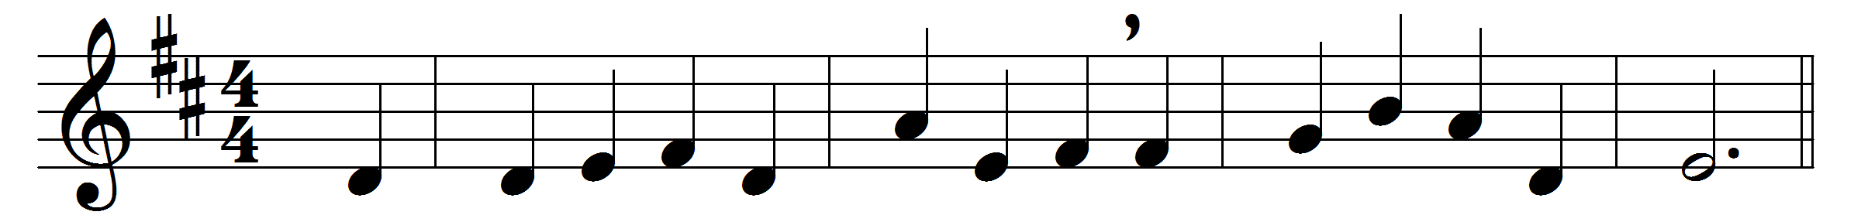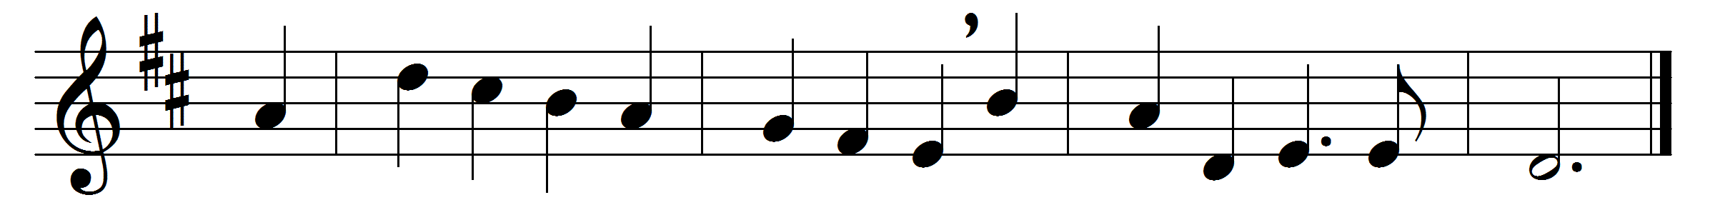

Lord, teach us how to pray aright
with reverence and with fear;
though dust and ashes in thy sight,
we may, we must, draw near.
We perish if we cease from prayer:
O grant us power to pray;
and, when to meet thee we prepare,
Lord, meet us by the way.
God of all grace, we bring to thee
a broken, contrite heart;
give what thine eye delights to see,
truth in the inward part;

faith in the only sacrifice
that can for sin atone,
to cast our hopes, to fix our eyes,
on Christ, on Christ alone;
patience to watch and wait and weep,
though mercy long delay;
courage our fainting souls to keep,
and trust thee though thou slay.

Give these, and then thy will be done;
thus, strengthened with all might,
we, through thy Spirit and thy Son,
shall pray, and pray aright.

Words: James Montgomery (1771-1854)
Music: Edward John Hopkins (1818-1901)

