As pants the hart for cooling streams AMNS 226 Melody: Martyrdom C.M.
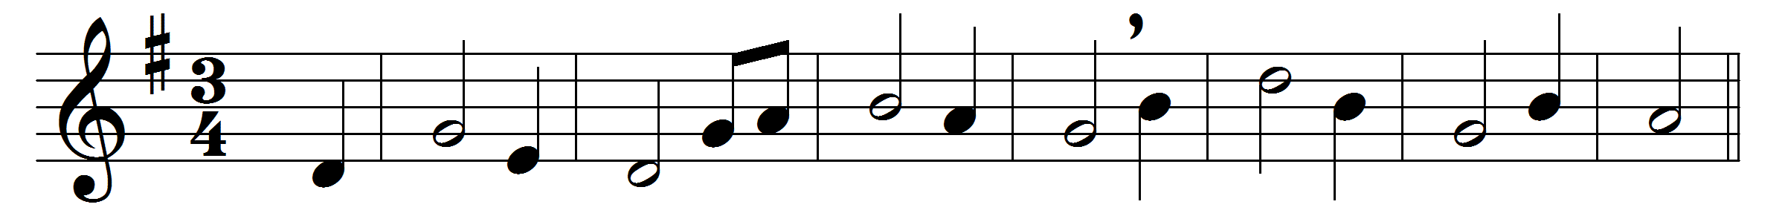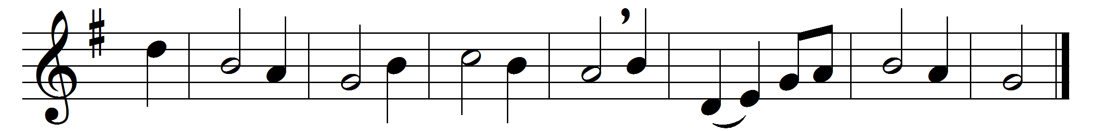

As pants the hart for cooling streams
when heated in the chase,
so longs my soul, O God, for thee,
and thy refreshing grace.
For thee, my God, the living God,
my thirsty soul doth pine:
O when shall I behold thy face,
thou majesty divine?
Why restless, why cast down, my soul?
hope still, and thou shalt sing
the praise of him who is thy God,
thy health’s eternal spring.
To Father, Son, and Holy Ghost,
the God whom we adore,
be glory, as it was, is now,
and shall be evermore.

Words: Psalm 42 in New Version (Tate and Brady, 1696)
Music: Melody by Hugh Wilson (1766-1824)

