Lead us, heavenly Father, lead us AMNS 224 Melody: Mannheim (E major as in AMR) 8 7. 8 7. 8 7.
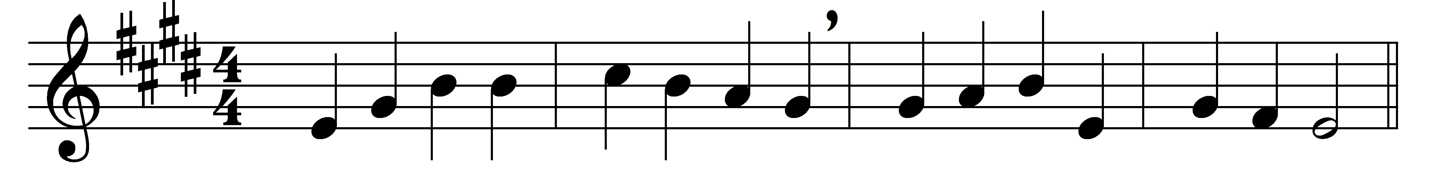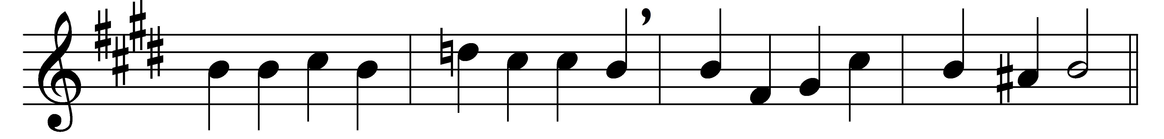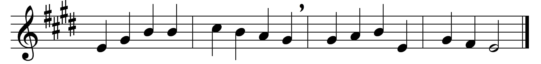

Lead us, heavenly Father, lead us
o’er the world’s tempestuous sea;
guard us, guide us, keep us, feed us,
for we have no help but thee;
yet possessing every blessing,
if our God our Father be.

Saviour, breathe forgiveness o’er us:
all our weakness thou dost know;
thou didst tread this earth before us,
thou didst feel its keenest woe;
lone and dreary, faint and weary,
through the desert thou didst go.

Spirit of our God, descending,
fill our hearts with heavenly joy,
love with every passion blending,
pleasure that can never cloy:
thus provided, pardoned, guided,
nothing can our peace destroy.

Words: James Edmeston (1791-1867)
Music: Adapted from Friedrich Filitz’s Choralbuch (1847)

