This is the day of light AMNS 21 Melody: Dominica S.M.
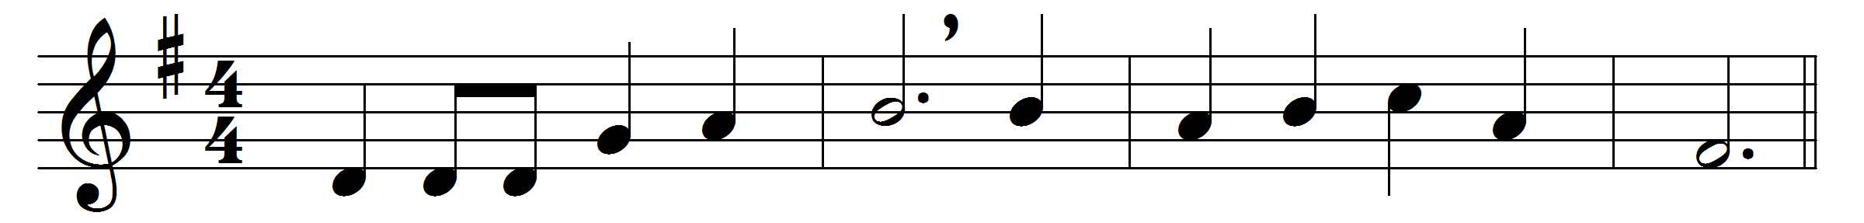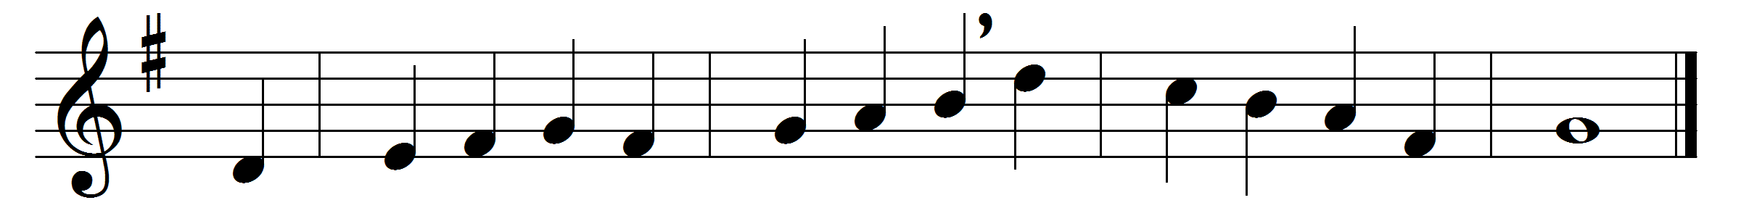

This is the day of light:
let there be light to-day;
O Dayspring, rise upon our night,
and chase its gloom away.
This is the day of rest:
our failing strength renew;
on weary brain and troubled breast
shed thou thy freshening dew.
This is the day of peace:
thy peace our spirits fill;
bid thou the blasts of discord cease,
the waves of strife be still.
This is the day of prayer:
let earth to heaven draw near;
lift up our hearts to seek thee there,
come down to meet us here.
This is the first of days:
send forth thy quickening breath,
and wake dead souls to love and praise,
O vanquisher of death.

Words: John Ellerton (1826-1893)
Music: Herbert Stanley Oakley (1830-1903)

