He that is down needs fear no fall AMNS 218 Melody: York C.M.
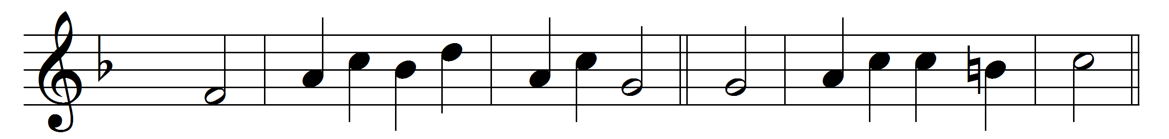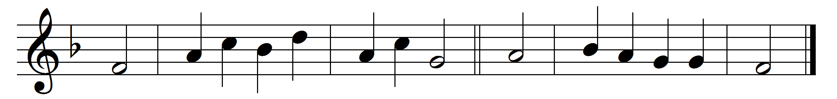

He that is down needs fear no fall,
he that is low no pride;
he that is humble ever shall
have God to be his guide.
I am content with what I have,
little be it or much;
and, Lord, contentment still I crave,
because thou savest such.
Fullness to such a burden is
that go on pilgrimage;
here little, and hereafter bliss,
is best from age to age.

Words: John Bunyan (1628-1688)
Music: Melody from Scottish Psalter, 1615

