Children of the heavenly King AMNS 213 Melody: Bewdley 7 7. 7 7.
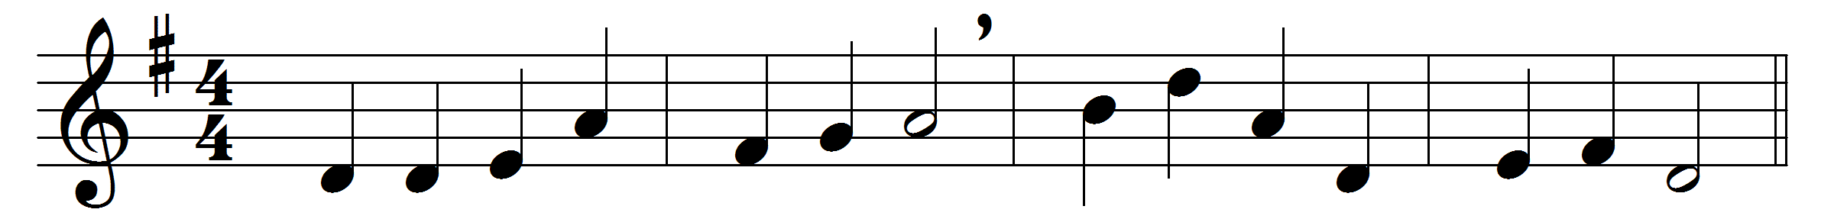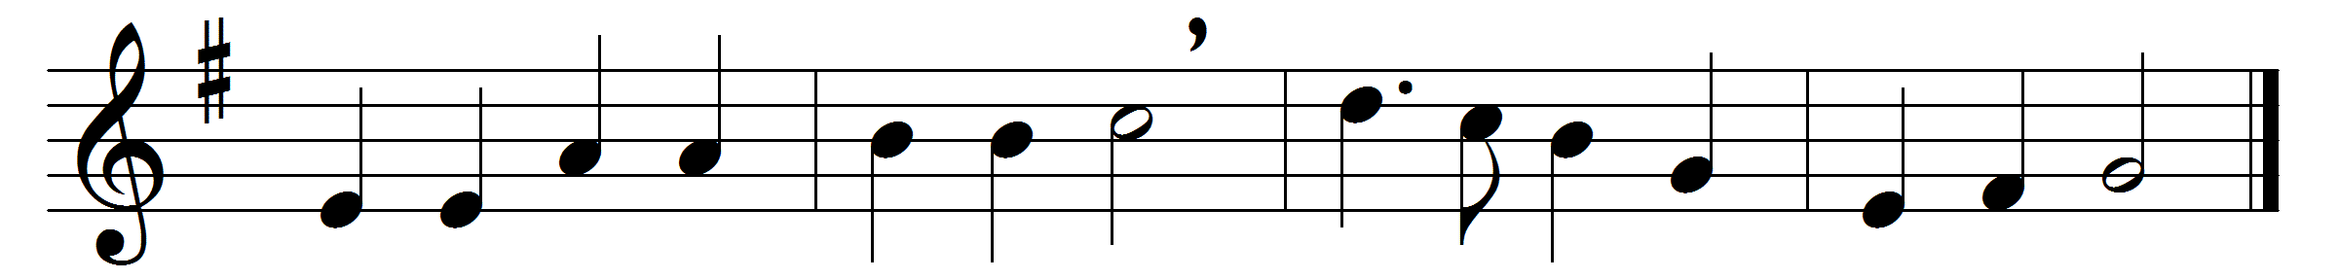

Children of the heavenly King,
as ye journey, sweetly sing;
sing your Saviour’s worthy praise,
glorious in his works and ways.
We are travelling home to God
in the way the fathers trod;
they are happy now, and we
soon their happiness shall see.
Lift your eyes, ye sons of light!
Sion’s city is in sight;
there our endless home shall be,
there our Lord we soon shall see.
Fear not, brethren! joyful stand
on the borders of your land;
Jesus Christ, your Father’s Son,
bids you undismayed go on.
Lord, obedient we would go,
gladly leaving all below;
only thou our leader be,
and we still will follow thee.

Words: John Cennick (1718-1755)
Music: Frederick Arthur Gore Ouseley (1825-1889)

