Who would true valour see AMNS 212 Melody: Bunyan 6 5. 6 5. 6 6. 6 5.
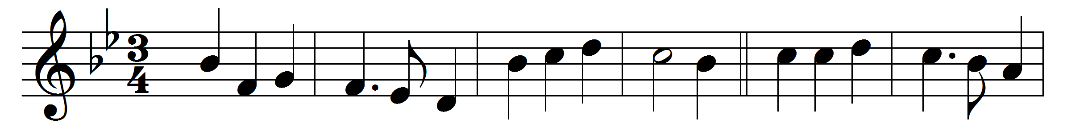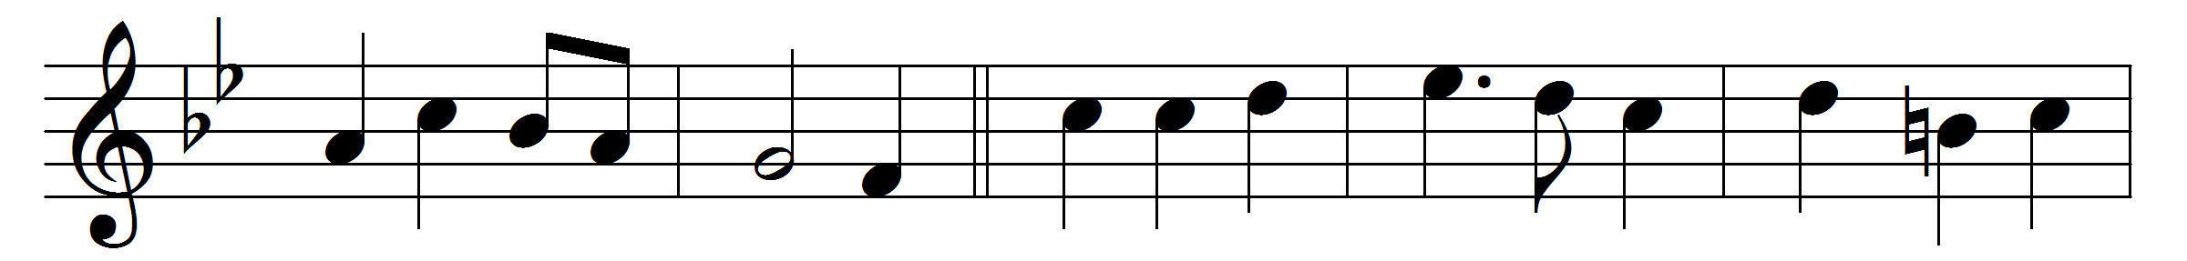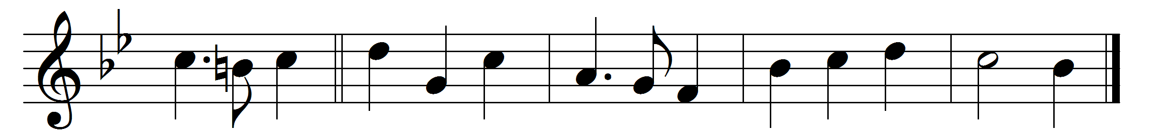

Who would true valour see,
let him come hither;
one here will constant be,
come wind, come weather;
there’s no discouragement
shall make him once relent
his first avowed intent
to be a pilgrim.
Whoso beset him round
with dismal stories,
do but themselves confound;
his strength the more is.
No lion can him fright;
he’ll with a giant fight,
but he will have the right
to be a pilgrim.
No goblin nor foul fiend
can daunt his spirit;
he knows he at the end
shall life inherit.
Then, fancies, fly away;
he’ll not fear what men say;
he’ll labour night and day
to be a pilgrim.

Words: John Bunyan (1628-1688)
Music: Christen-Schatz (Basle, 1745)

