We would extol thee AMNS 206 Melody: Old 124th 10 10. 10 10. 10.

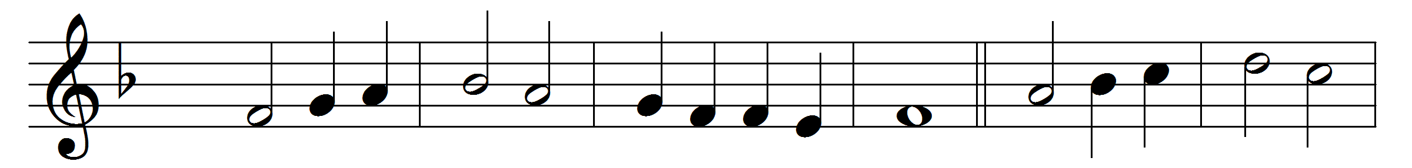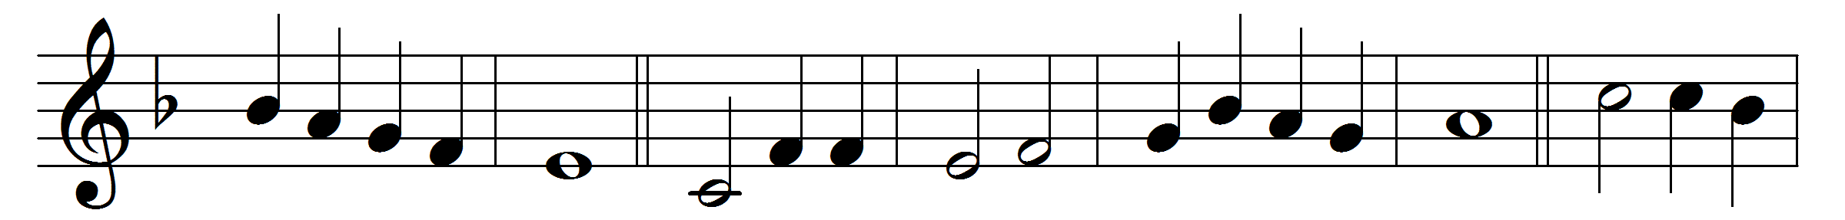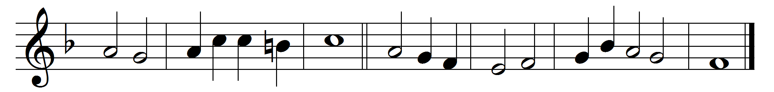

We would extol thee, ever-blessèd Lord;

thy holy name for ever be adored;

each day we live to thee our psalm we raise:

thou, God and King, art worthy of our praise,

great and unsearchable in all thy ways.

Age shall to age pass on the endless song,

telling the wonders which to thee belong,

thy mighty acts with joy and fear relate;

laud we thy glory while on thee we wait,

glad in the knowledge of thy love so great.

Thou, Lord, art gracious, merciful to all,

nigh to thy children when on thee they call;

slow unto anger, pitiful and kind,

thou to compassion ever art inclined:

we love thee with our heart and strength and mind.

Words: Nichol Grieve (1868-1954)

Music: Melody from *Genevan Psalter*, 1551