Now thank we all our God AMNS 205 Melody: Nun danket 6 7. 6 7. 6 6. 6 6.
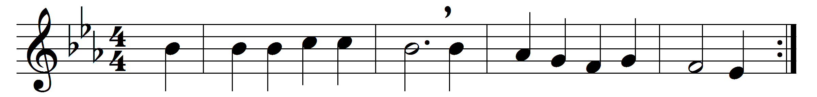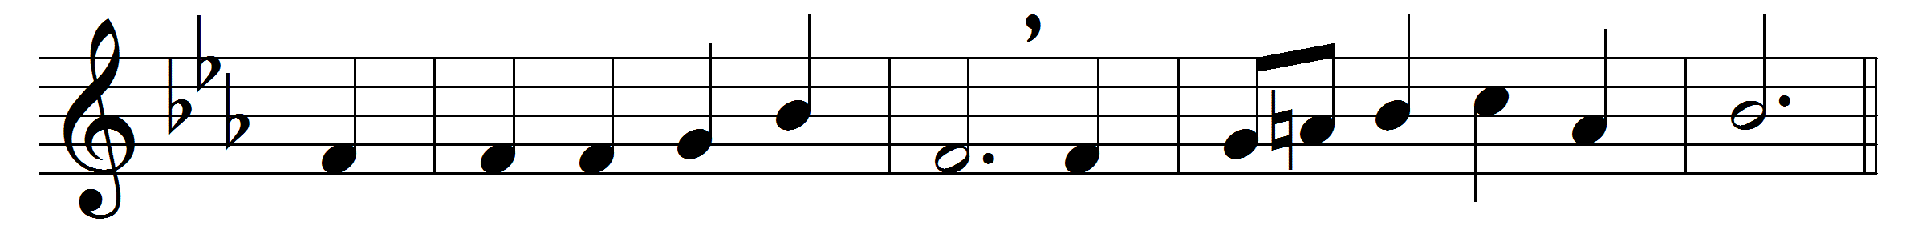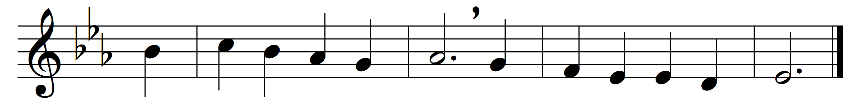

Now thank we all our God,
with heart and hands and voices,
who wondrous things hath done,
in whom his world rejoices;
who from our mother’s arms
hath blessed us on our way
with countless gifts of love,
and still is ours to-day.
O may this bounteous God
through all our life be near us,
with ever joyful hearts
and blessèd peace to cheer us;
and keep us in his grace,
and guide us when perplexed,
and free us from all ills
in this world and the next.
All praise and thanks to God
the Father now be given,
the Son, and him who reigns
with them in highest heaven,
the one eternal God,
whom earth and heaven adore,
for thus it was, is now,
and shall be evermore.

Words: Martin Rinkart (1586-1649), translated by Catherine Winkworth (1827-1878)
Music: Later form of a melody from Johann Crüger’s Praxis Pietatis Melica (c. 1647)

