Let us, with a gladsome mind AMNS 204 Melody: Monkland 7 7. 7 7.
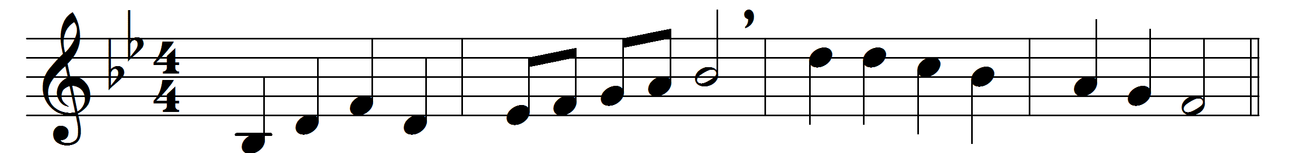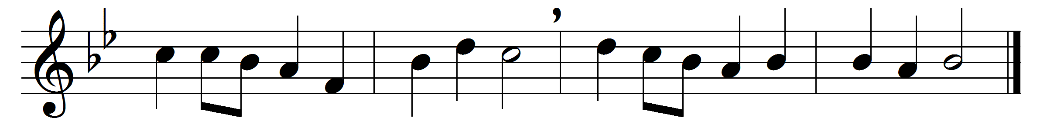

Let us, with a gladsome mind,
praise the Lord, for he is kind:
for his mercies ay endure,
ever faithful, ever sure.
Let us blaze his name abroad,
for of gods he is the God:
He with all-commanding might
filled the new-made world with light:
He the golden-tressèd sun
caused all day his course to run:

And the hornèd moon at night
’mid her spangled sisters bright:

All things living he doth feed,
his full hand supplies their need:

Let us, with a gladsome mind,
praise the Lord, for he is kind:
for his mercies ay endure,
ever faithful, ever sure.
Words: John Milton (1608-1674)
Music: John Antes (1740-1811), arranged by John Wilkes (1785-1869)

