Stand up, and bless the Lord AMNS 201 Melody: Carlisle S.M.
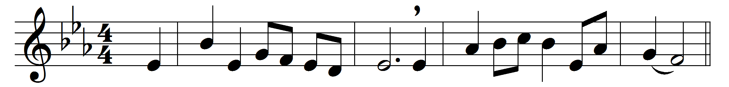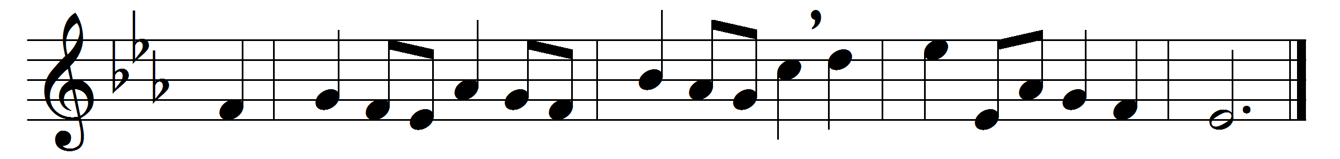

Stand up, and bless the Lord,
ye people of his choice;
stand up, and bless the Lord your God
with heart and soul and voice.
Though high above all praise,
above all blessing high,
who would not fear his holy name,
and laud and magnify?
O for the living flame
from his own altar brought,
to touch our lips, our mind inspire,
and wing to heaven our thought.
God is our strength and song,
and his salvation ours;
then be his love in Christ proclaimed
with all our ransomed powers.
Stand up, and bless the Lord,
the Lord your God adore;
stand up, and bless his glorious name
henceforth for evermore.

Words: James Montgomery (1771-1854)
Music: Charles Lockhart (1745-1815)

