Fill thou my life, O Lord my God AMNS 200 Melody: Richmond C.M.
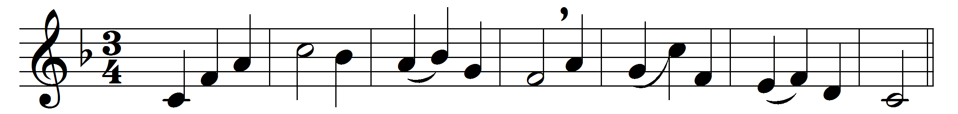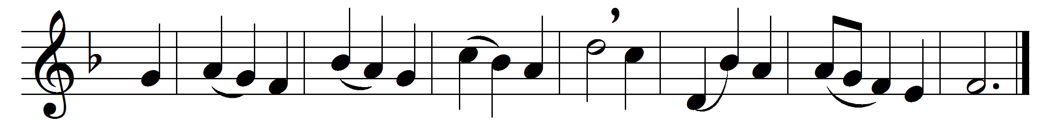

Fill thou my life, O Lord my God,
in every part with praise,
that my whole being may proclaim
thy being and thy ways.
Not for the lip of praise alone,
nor e’en the praising heart,
I ask, but for a life made up
of praise in every part:
praise in the common things of life,
its goings out and in;
praise in each duty and each deed,
however small and mean.

Fill every part of me with praise:
let all my being speak
of thee and of thy love, O Lord,
poor though I be and weak.

So shalt thou, Lord, receive from me
the praise and glory due;
and so shall I begin on earth
the song for ever new.

So shall each fear, each fret, each care,
be turnèd into song;
and every winding of the way
the echo shall prolong.
So shall no part of day or night
unblest or common be;
but all my life, in every step,
be fellowship with thee.

Words: Horatius Bonar (1808-1889)
Music: Melody adapted from Thomas Haweis (1734-1820)

