Songs of praise the angels sang AMNS 196 Melody: Northampton 7 7. 7 7.
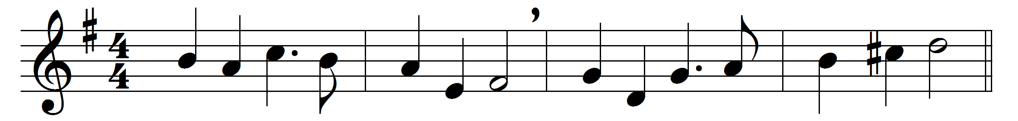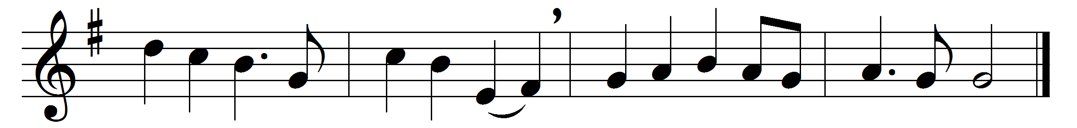

Songs of praise the angels sang,
heaven with alleluias rang,
when creation was begun,
when God spake and it was done.

Songs of praise awoke the morn
when the Prince of Peace was born;
songs of praise arose when he
captive led captivity.

Heaven and earth must pass away;
songs of praise shall crown that day:
God will make new heavens and earth;
songs of praise shall hail their birth.

And will man alone be dumb
till that glorious kingdom come?
No, the Church delights to raise
psalms and hymns and songs of praise.

Saints below, with heart and voice,
still in songs of praise rejoice;
learning here, by faith and love,
songs of praise to sing above.

Hymns of glory, songs of praise,
Father, unto thee we raise,
Jesu, glory unto thee,
with the Spirit, ever be.

Words: James Montgomery (1771-1854)
Music: Charles John King (1859-1934)

