King of glory, King of peace AMNS 194 Melody: Gwalchmai 7 4. 7 4. D.
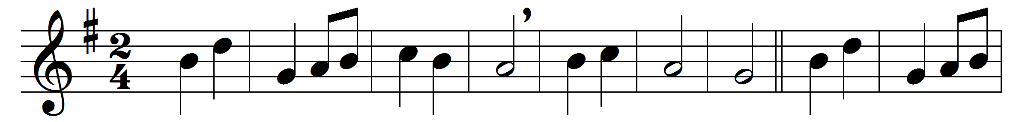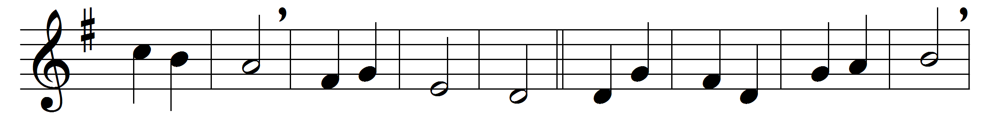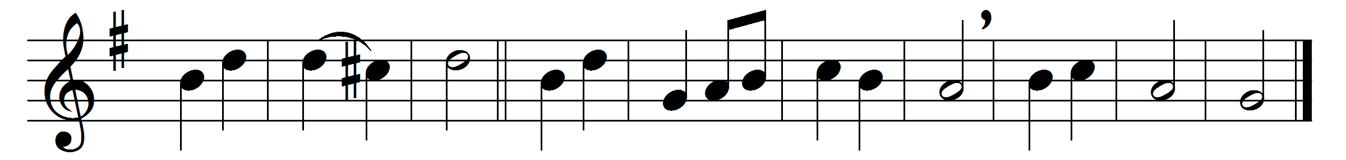

King of glory, King of peace,
I will love thee;
and, that love may never cease,
I will move thee.
Thou hast granted my request,
thou hast heard me;
thou didst note my working breast,
thou hast spared me.
Wherefore with my utmost art
I will sing thee,
and the cream of all my heart
I will bring thee.
Though my sins against me cried,
thou didst clear me,
and alone, when they replied,
thou didst hear me.
Seven whole days, not one in seven,
I will praise thee;
in my heart, though not in heaven,
I can raise thee.
Small it is, in this poor sort
to enrol thee:
e’en eternity’s too short
to extol thee.

Words: George Herbert (1593-1632)
Music: Joseph David Jones (1827-1870)

