Sing praise to God who reigns above AMNS 193 Melody: Luther’s Hymn 8 7. 8 7. 8 8 7.
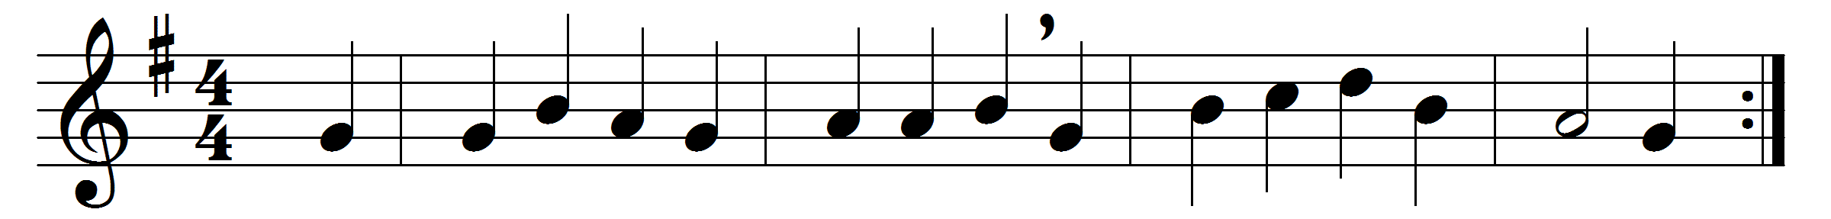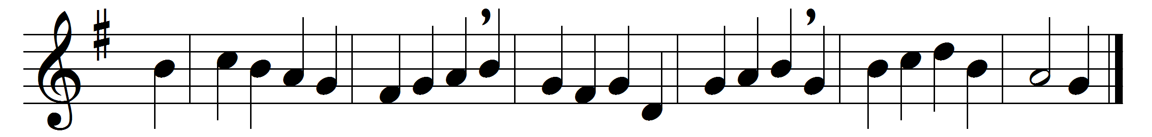

Sing praise to God who reigns above,
the God of all creation,
the God of power, the God of love,
the God of our salvation;
with healing balm my soul he fills,
and every faithless murmur stills:
to God all praise and glory.
The Lord is never far away,
but, through all grief distressing,
an ever-present help and stay,
our peace and joy and blessing;
as with a mother’s tender hand,
he leads his own, his chosen band:
to God all praise and glory.
Thus all my gladsome way along
I sing aloud thy praises,
that men may hear the grateful song
my voice unwearied raises;
be joyful in the Lord, my heart;
both soul and body bear your part:
to God all praise and glory.
Words: Johann Jakob Schütz (1640-1690), translated by Frances Elizabeth Cox (1812-1897)
Music: Later form of melody in Geistliche Lieder (1533 or earlier)

