Praise, my soul, the King of heaven AMNS 192 Melody: Praise, My Soul 8 7. 8 7. 8 7.
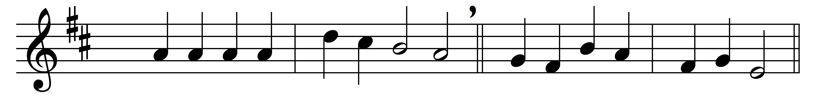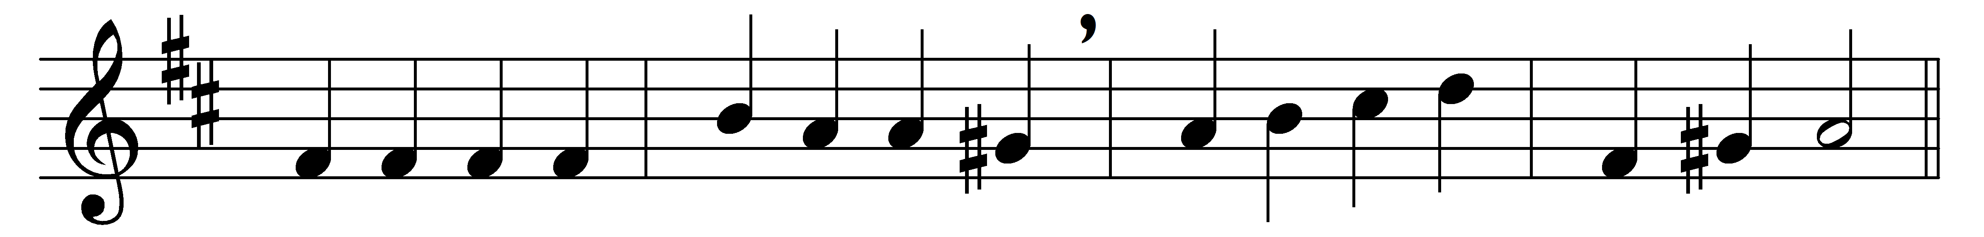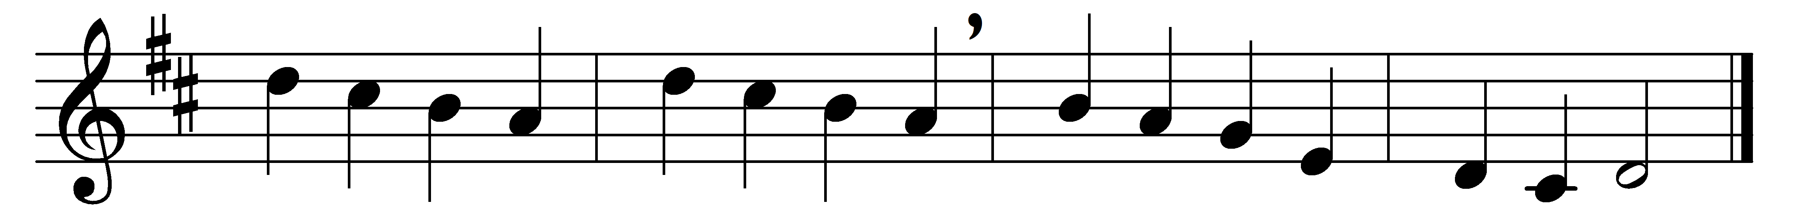

Praise, my soul, the King of heaven,
to his feet thy tribute bring;
ransomed, healed, restored, forgiven,
who like me his praise should sing?
Alleluia, Alleluia,
praise the everlasting King.

Praise him for his grace and favour
to our fathers in distress;
praise him still the same as ever,
slow to chide, and swift to bless:
Alleluia, Alleluia,
glorious in his faithfulness.

Father-like, he tends and spares us,
well our feeble frame he knows;
in his hands he gently bears us,
rescues us from all our foes:
Alleluia, Alleluia,
widely as his mercy flows.

Angels, help us to adore him;
ye behold him face to face;
sun and moon, bow down before him,
dwellers all in time and space:
Alleluia, Alleluia,
praise with us the God of grace.

Words: Henry Francis Lyte (1793-1847)
Music: John Goss (1800-1880)

