Round me falls the night AMNS 18 Melody: Seelenbräutigam (Thuringia) 5 5. 8 8. 5 5.
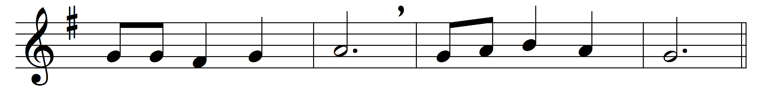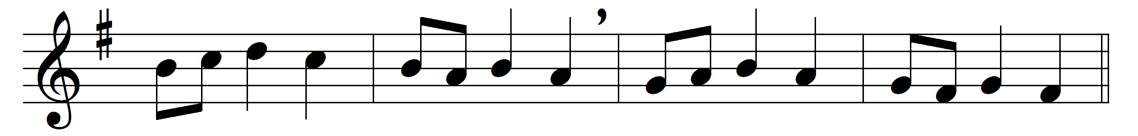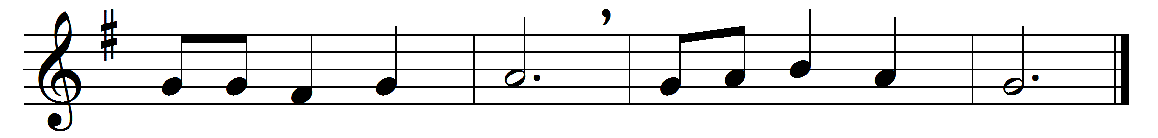

Round me falls the night;
Saviour, be my light;
through the hours in darkness shrouded
let me see thy face unclouded;
let thy glory shine
in this heart of mine.
Earthly work is done,
earthly sounds are none;
rest in sleep and silence seeking,
let me hear thee softly speaking;
in my spirit’s ear
whisper, ‘I am near.’
Blessèd, heavenly Light,
shining through earth’s night;
voice, that oft of love hast told me;
arms, so strong to clasp and hold me;
thou thy watch wilt keep,
Saviour, o’er my sleep.

Words: William Romanis (1824-1899)
Music: Adam Drese (1620-1701), harmonised by Friedrich Layriz (1844)

