Sing alleluia forth in duteous praise AMNS 188 Melody: St. Sebastian 10 10. 7.
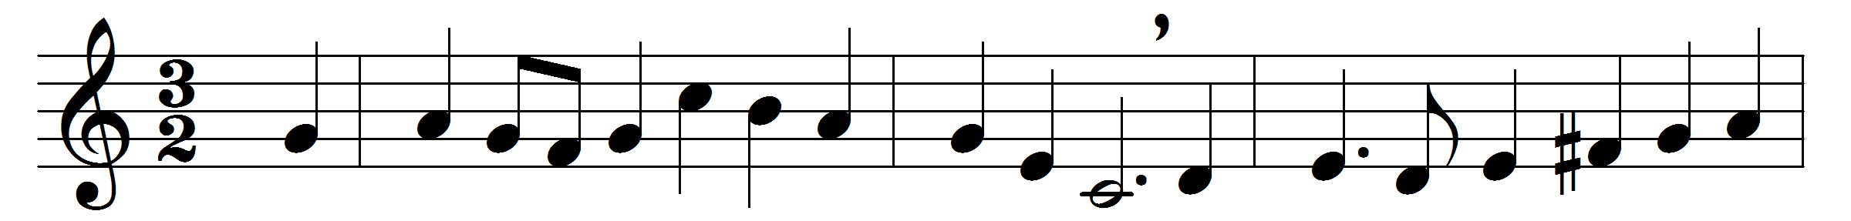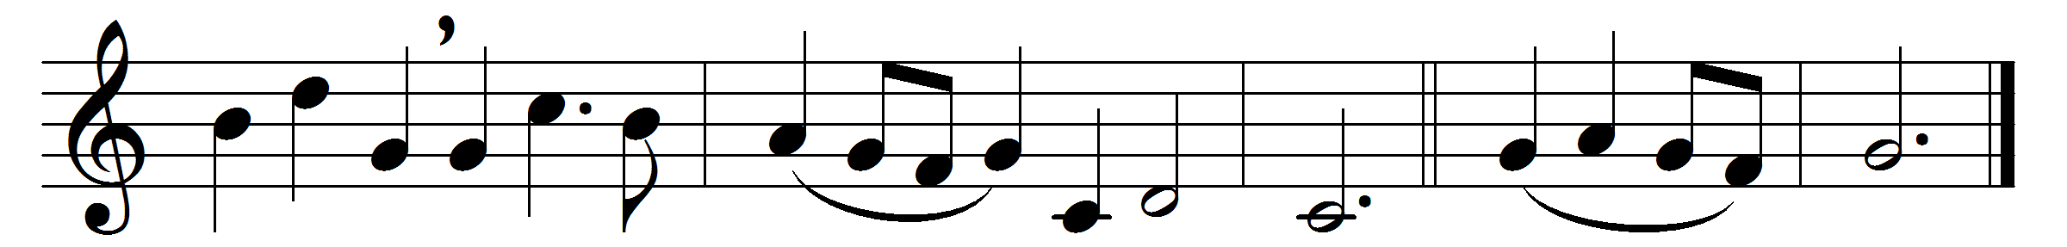

Sing alleluia forth in duteous praise,
ye citizens of heaven; O sweetly raise
an endless alleluia.
Ye powers who stand before the eternal Light,
in hymning choirs re-echo to the height
an endless alleluia.
The holy city shall take up your strain,
and with glad songs resounding wake again
an endless alleluia.
In blissful antiphons ye thus rejoice
to render to the Lord with thankful voice
an endless alleluia.
Ye who have gained at length your palms in bliss,
victorious ones, your chant shall still be this:
an endless alleluia.
There, in one grand acclaim, for ever ring
the strains which tell the honour of your King:
an endless alleluia.
This is sweet rest for weary ones brought back,
this is glad food and drink which ne’er shall lack:
an endless alleluia.
While thee, by whom were all things made, we praise
for ever, and tell out in sweetest lays
an endless alleluia.
Almighty Christ, to thee our voices sing
glory for evermore; to thee we bring
an endless alleluia. Amen.

Words: Mozarabic (5th to 8th centuries), translated by John Ellerton (1828-1893)
Music: Percy Carter Buck (1871-1947)

