Jerusalem, my happy home AMNS 187 Melody: Southwell (Irons) C.M.
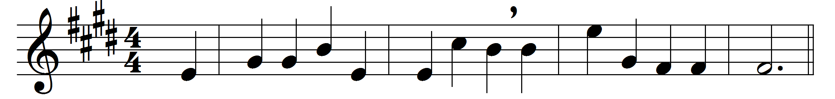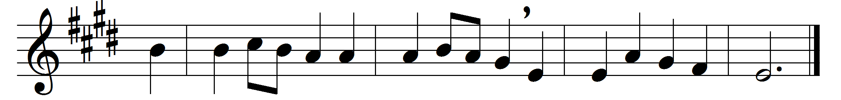

Jerusalem, my happy home,
name ever dear to me,
when shall my labours have an end?
thy joys when shall I see?
When shall these eyes thy heaven-built walls
and pearly gates behold?
thy bulwarks with salvation strong,
and streets of shining gold?
Apostles, martyrs, prophets, there
around my Saviour stand;
and all I love in Christ below
will join the glorious band.
Jerusalem, my happy home,
when shall I come to thee?
when shall my labours have an end?
thy joys when shall I see?
O Christ, do thou my soul prepare
for that bright home of love;
that I may see thee and adore,
with all thy saints above.

Words: Based on “F. B. P.”, c. 1600
Music: Herbert Stephen Irons (1834-1905)

