O what their joy and their glory must be AMNS 186 Melody: O quanta qualia 10 10. 10 10.
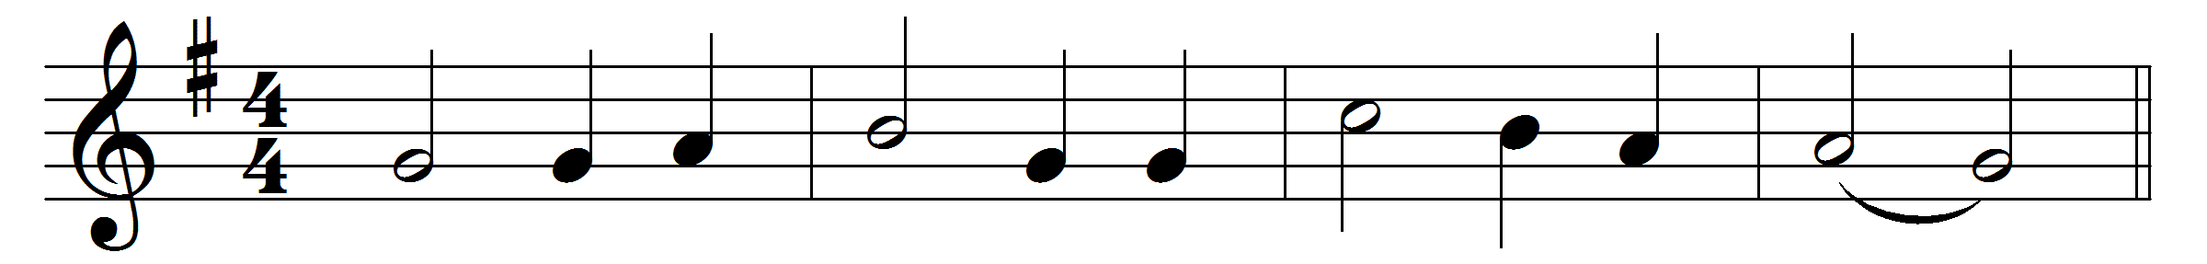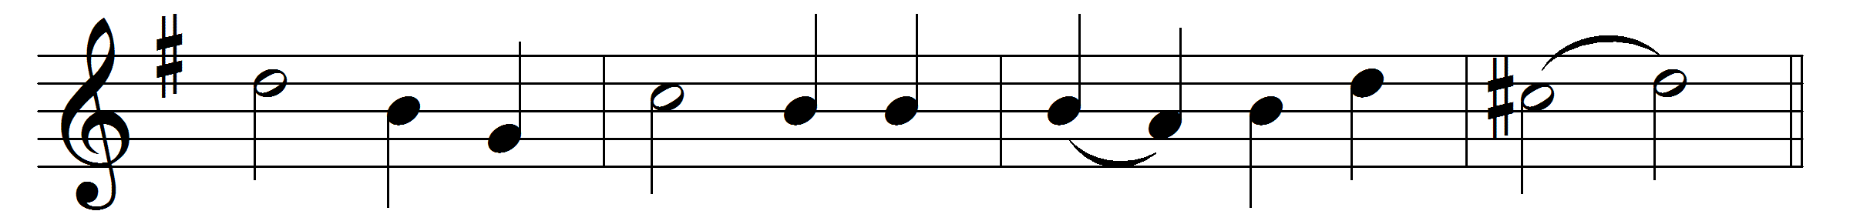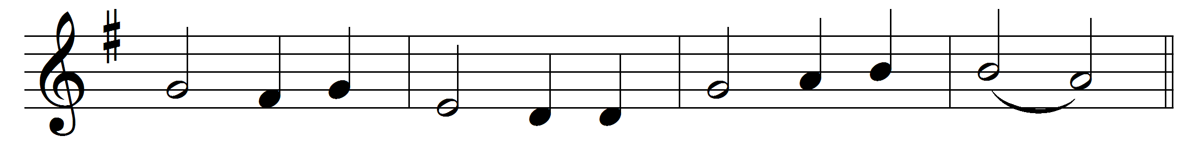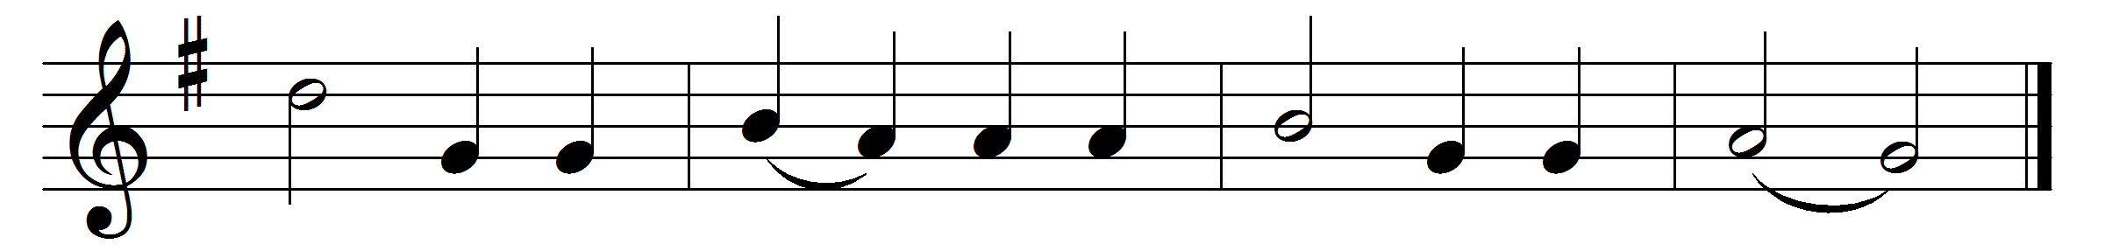

O what their joy and their glory must be,
those endless sabbaths the blessèd ones see;
crown for the valiant, to weary ones rest;
God shall be all, and in all ever blest.
What are the Monarch, his court, and his throne?
what are the peace and the joy that they own?
O that the blest ones, who in it have share,
all that they feel could as fully declare.
Truly, Jerusalem name we that shore,
‘Vision of Peace,’ that brings joy evermore.
Wish and fulfilment can severed be ne’er,
nor the thing prayed for come short of the prayer.
There, where no troubles distraction can bring,
we the sweet anthems of Sion shall sing,
while for thy grace, Lord, their voices of praise
thy blessèd people eternally raise.
There dawns no sabbath, no sabbath is o’er,
those sabbath-keepers have one evermore;
one and unending is that triumph-song
which to the angels and us shall belong.
Now in the meanwhile, with hearts raised on high,
we for that country must yearn and must sigh;
seeking Jerusalem, dear native land,
through our long exile on Babylon’s strand.
Low before him with our praises we fall,
of whom, and in whom, and through whom are all:
of whom, the Father; and in whom, the Son;
through whom, the Spirit, with them ever One.

Words: Peter Abelard (1079-1142), translated by John Mason Neale (1818-1866)
Music: La Feillée, Méthode, 1808

