Jerusalem the golden AMNS 184 Melody: Ewing 7 6. 7 6. D.
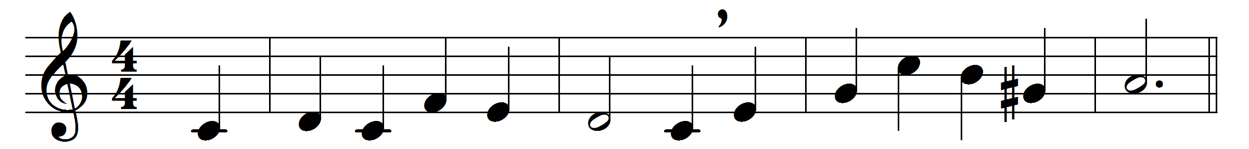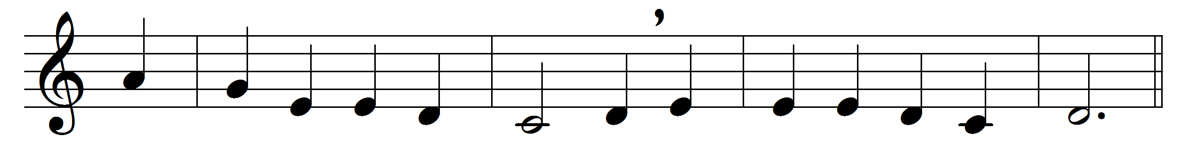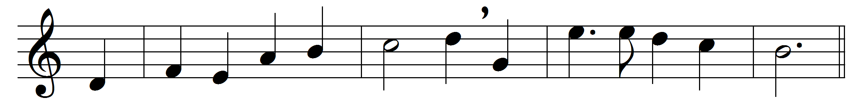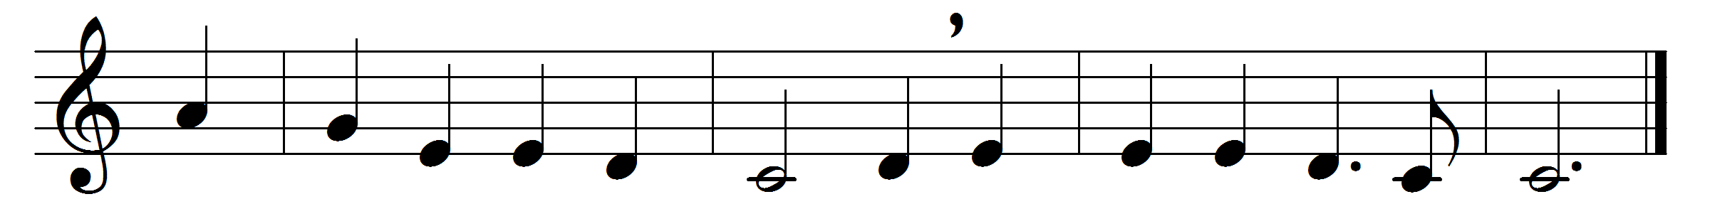

Jerusalem the golden,
with milk and honey blest,
beneath thy contemplation
sink heart and voice opprest.
I know not, O I know not
what joys await us there,
what radiancy of glory,
what bliss beyond compare.
They stand, those halls of Sion,
all jubilant with song,
and bright with many an angel,
and all the martyr throng;
the Prince is ever with them,
the daylight is serene,
the pastures of the blessèd
are decked in glorious sheen.
There is the throne of David;
and there, from care released,
the shout of them that triumph,
the song of them that feast;
and they, who with their Leader
have conquered in the fight,
for ever and for ever
are clad in robes of white.
O sweet and blessèd country,
the home of God’s elect!
O sweet and blessèd country
that eager hearts expect!
Jesu, in mercy bring us
to that dear land of rest;
who art, with God the Father
and Spirit, ever blest.

Words: Bernard of Cluny (12th century), translated by John Mason Neale (1818-1866)
Music: Alexander Ewing (1830-1895)

