The duteous day now closeth AMNS 17 Melody: Innsbruck 7 7 6. 7 7 8.
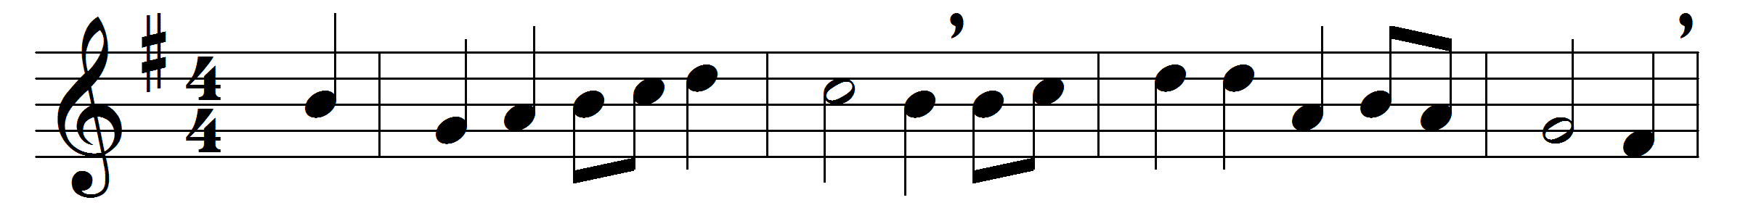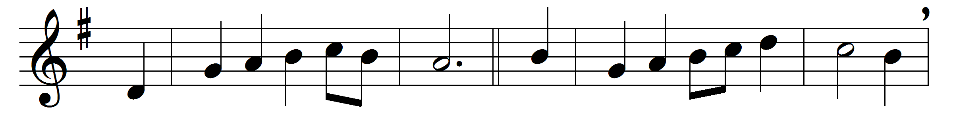

The duteous day now closeth,
each flower and tree reposeth,
shade creeps o’er wild and wood:
let us, as night is falling,
on God our Maker calling,
give thanks to him, the giver good.
Now all the heavenly splendour
breaks forth in starlight tender
from myriad worlds unknown;
and man, the marvel seeing,
forgets his selfish being,
for joy of beauty not his own.
His care he drowneth yonder,
lost in the abyss of wonder;
to heaven his soul doth steal:
this life he disesteemeth,
the day it is that dreameth,
that doth from truth his vision seal.
Awhile his mortal blindness
may miss God’s loving-kindness,
and grope in faithless strife:
but when life’s day is over
shall death’s fair night discover
the fields of everlasting life.

Words: Robert Bridges (1844-1930), based on Nun ruhen alle Wälder by Paul Gerhardt (1607-1676)
Music: German folksong

