Ye that know the Lord is gracious AMNS 175 Melody: Hyfrydol 8 7. 8 7. D.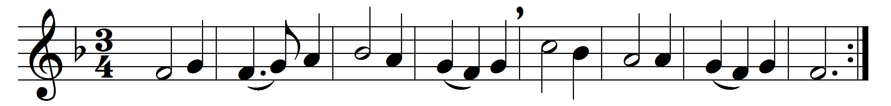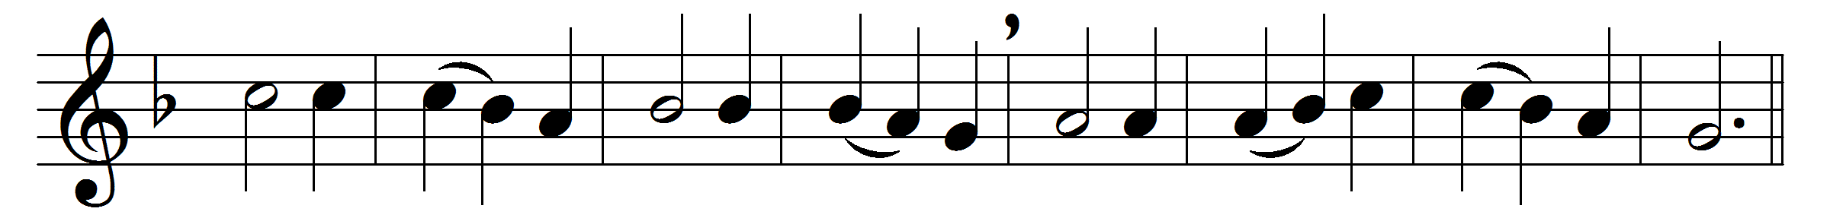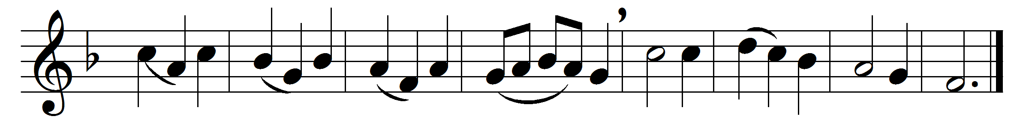

Ye that know the Lord is gracious,
ye for whom a Corner-stone
stands, of God elect and precious,
laid that ye may build thereon,
see that on that sure foundation
ye a living temple raise,
towers that may tell forth salvation,
walls that may re-echo praise.

Living stones, by God appointed
each to his allotted place,
kings and priests, by God anointed,
shall ye not declare his grace?
Ye, a royal generation,
tell the tidings of your birth,
tidings of a new creation
to an old and weary earth.

Tell the praise of him who called you
out of darkness into light,
broke the fetters that enthralled you,
gave you freedom, peace and sight:
tell the tale of sins forgiven,
strength renewed and hope restored,
till the earth, in tune with heaven,
praise and magnify the Lord.

Words: Cyril A. Alington (1872-1955)
Music: Melody by Rowland Hugh Prichard (1811-1887)

