City of God, how broad and far AMNS 173 Melody: Richmond C.M.
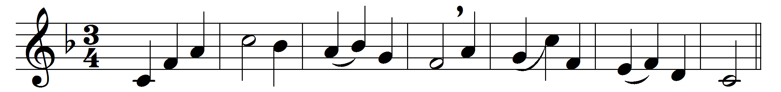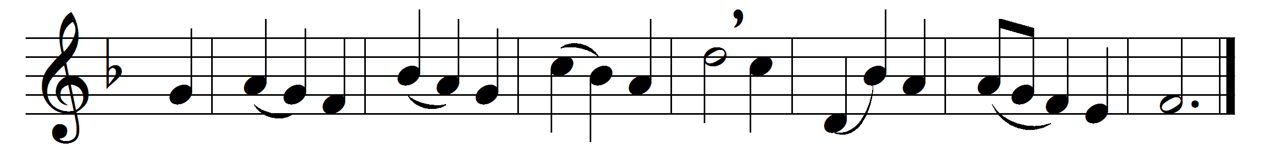

City of God, how broad and far
outspread thy walls sublime!
the true thy chartered freemen are
of every age and clime:

one holy church, one army strong,
one steadfast, high intent;
one working band, one harvest-song,
one King omnipotent.

How purely hath thy speech come down
from man’s primeval youth!
how grandly hath thine empire grown
of freedom, love, and truth!

How gleam thy watch-fires through the night
with never-fainting ray!
how rise thy towers, serene and bright,
to meet the dawning day!

In vain the surge’s angry shock,
in vain the drifting sands:
unharmed upon the eternal Rock
the eternal city stands.

Words: Samuel Johnson (1822-1882)
Music: Melody adapted from Thomas Haweis (1734-1820)

