Glorious things of thee are spoken AMNS 172 Melody: Austria 8 7. 8 7. D.
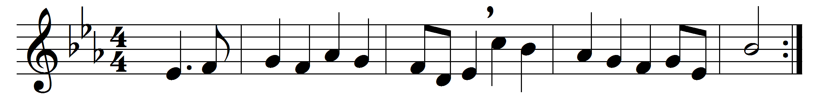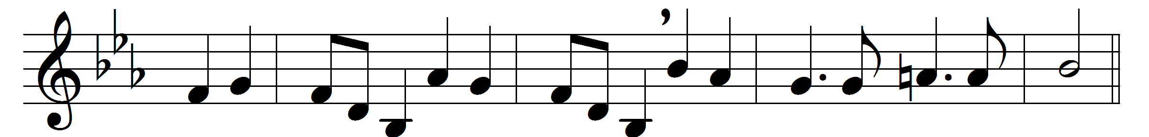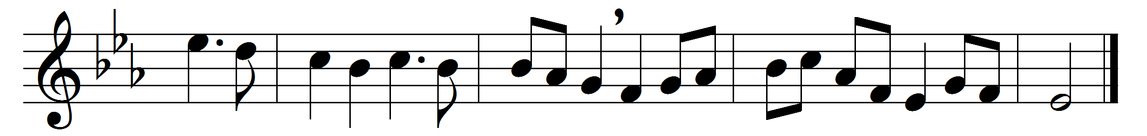

Glorious things of thee are spoken,
Zion, city of our God;
he whose word cannot be broken
formed thee for his own abode.
On the Rock of ages founded,
what can shake thy sure repose?
With salvation’s walls surrounded,
thou may’st smile at all thy foes.
See, the streams of living waters,
springing from eternal love,
well supply thy sons and daughters,
and all fear of want remove.
Who can faint while such a river
ever flows their thirst to assuage:
grace which, like the Lord the giver,
never fails from age to age?
Round each habitation hovering,
see the cloud and fire appear
for a glory and a covering,
showing that the Lord is near.
Thus they march, the pillar leading,
light by night and shade by day;
daily on the manna feeding
which he gives them when they pray.
Saviour, if of Zion’s city
I through grace a member am,
let the world deride or pity,
I will glory in thy name.
Fading is the worldling’s pleasure,
all his boasted pomp and show;
solid joys and lasting treasure
none but Zion’s children know.

Words: John Newton (1725-1807)
Music: Joseph Haydn (1732-1809)

