Thy hand, O God, has guided AMNS 171 Melody: Thornbury 7 6. 7 6. D.
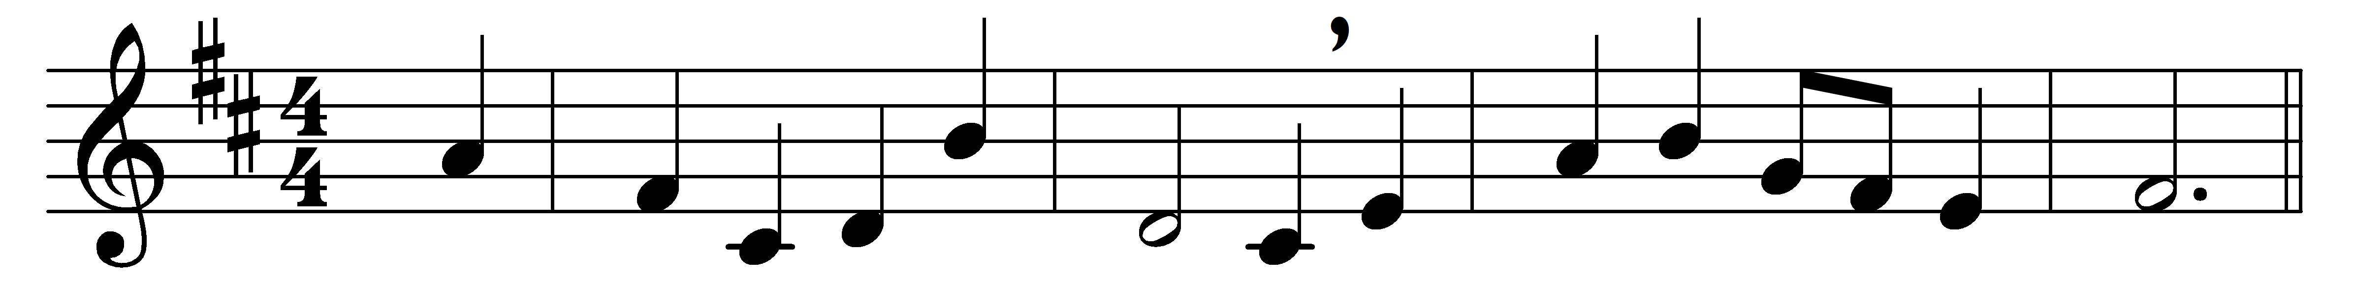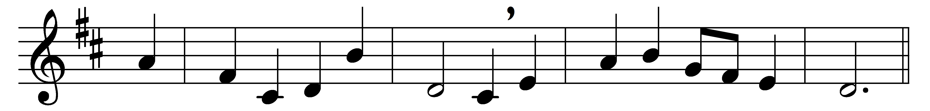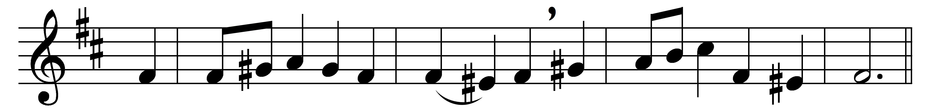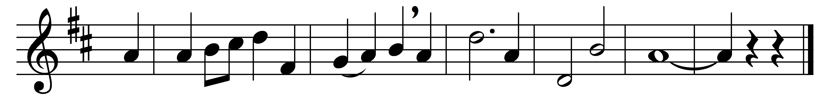

Thy hand, O God, has guided
thy flock, from age to age;
the wondrous tale is written,
full clear, on every page
our fathers owned thy goodness,
and we their deeds record;
and both of this bear witness:
one Church, one faith, one Lord.

Thy heralds brought glad tidings
to greatest, as to least;
they bade men rise, and hasten
to share the great King’s feast;
and this was all their teaching,
in every deed and word,
to all alike proclaiming
one Church, one faith, one Lord.

When shadows thick were falling,
and all seemed sunk in night,
thou, Lord, didst send thy servants,
thy chosen sons of light.
On them and on thy people
thy plenteous grace was poured,
and this was still their message:
one Church, one faith, one Lord.

Through many a day of darkness,
through many a scene of strife,
the faithful few fought bravely,
to guard the nation’s life.
Their Gospel of redemption,
sin pardoned, man restored,
was all in this enfolded:
one Church, one faith, one Lord.

And we, shall we be faithless?
shall hearts fail, hands hang down?
shall we evade the conflict,
and cast away our crown?
Not so: in God’s deep counsels
some better thing is stored;
we will maintain, unflinching,
one Church, one faith, one Lord.

Thy mercy will not fail us,
nor leave thy work undone;
with thy right hand to help us,
the victory shall be won;
and then, by men and angels,
thy name shall be adored,
and this shall be their anthem:
one Church, one faith, one Lord.

Words: Edward Hayes Plumptre (1821-1891)
Music: Basil Harwood (1859-1949)

