The Church’s one foundation AMNS 170 Melody: Aurelia 7 6. 7 6. D.
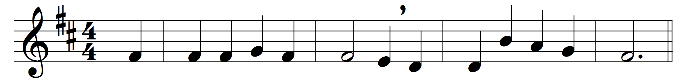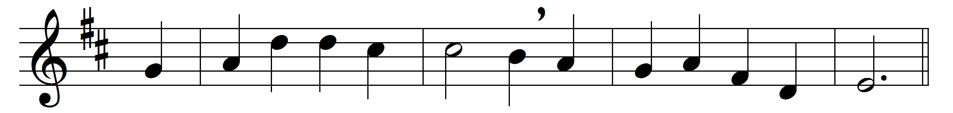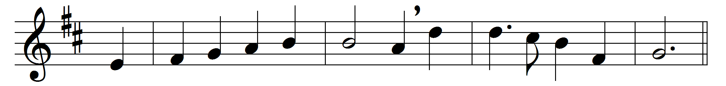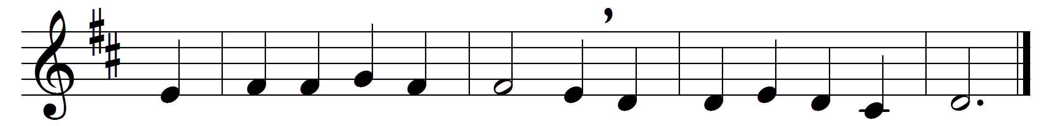

The Church’s one foundation
is Jesus Christ her Lord;
she is his new creation
by water and the word:
from heaven he came and sought her
to be his holy Bride;
with his own blood he bought her,
and for her life he died.
Elect from every nation,
yet one o’er all the earth,
her charter of salvation
one Lord, one faith, one birth;
one holy name she blesses,
partakes one holy food,
and to one hope she presses,
with every grace endued.
Though with a scornful wonder
men see her sore opprest,
by schisms rent asunder,
by heresies distrest,
yet saints their watch are keeping,
their cry goes up, ‘How long?’
and soon the night of weeping
shall be the morn of song.
Mid toil and tribulation,
and tumult of her war,
she waits the consummation
of peace for evermore;
till with the vision glorious
her longing eyes are blest,
and the great Church victorious
shall be the Church at rest.
Yet she on earth hath union
with God the Three in One,
and mystic sweet communion
with those whose rest is won:
O happy ones and holy!
Lord, give us grace that we,
like them the meek and lowly,
on high may dwell with thee.

Words: Samuel John Stone (1839-1900)
Music: Samuel Sebastian Wesley (1810-1876)

