The Church of God a kingdom is AMNS 169 Melody: University C.M.
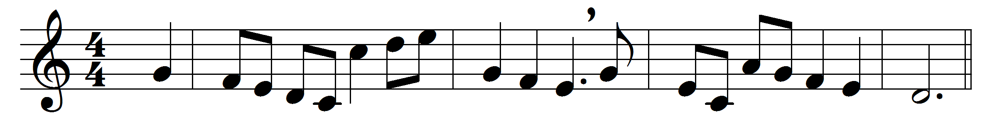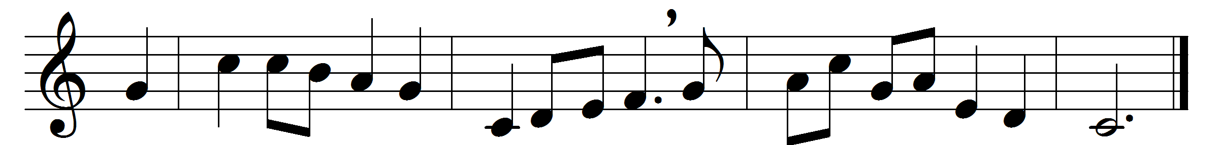

The Church of God a kingdom is,
where Christ in power doth reign;
where spirits yearn till, seen in bliss,
their Lord shall come again.
Glad companies of saints possess
this Church below, above;
and God’s perpetual calm doth bless
their paradise of love.
An altar stands within the shrine
whereon, once sacrificed,
is set, immaculate, divine,
the Lamb of God, the Christ.
There rich and poor, from countless lands,
praise Christ on mystic rood;
there nations reach forth holy hands
to take God’s holy food.
There pure life-giving streams o’erflow
the sower’s garden-ground;
and faith and hope fair blossoms show,
and fruits of love abound.
O King, O Christ, this endless grace
to us and all men bring,
to see the vision of thy face
in joy, O Christ, our King.

Words: Lionel Muirhead (1845-1925)
Music: Charles Collignon (1725-1785)

