Lord, thy word abideth AMNS 166 Melody: Ravenshaw 6 6. 6 6.
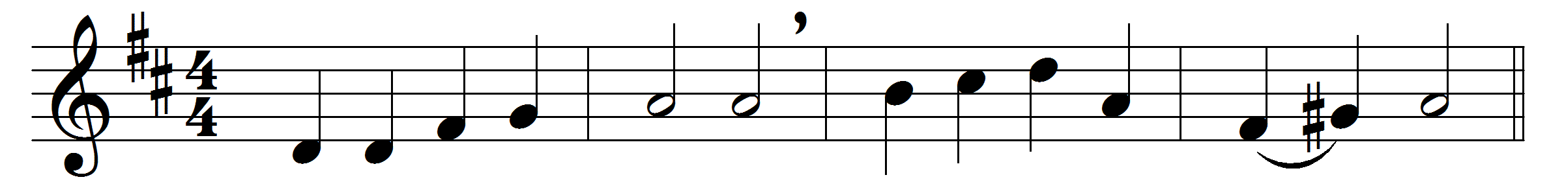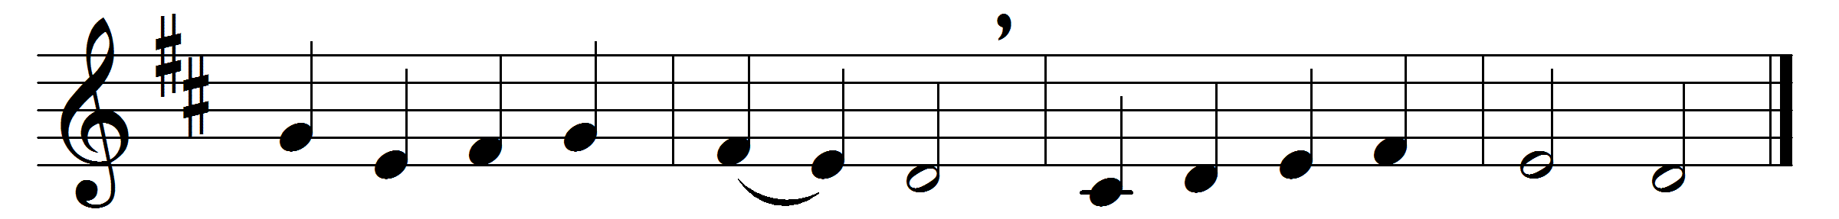

Lord, thy word abideth,
and our footsteps guideth;
who its truth believeth
light and joy receiveth.

When our foes are near us,
then thy word doth cheer us,
word of consolation,
message of salvation.

When the storms are o’er us,
and dark clouds before us,
then its light directeth,
and our way protecteth.

Who can tell the pleasure,
who recount the treasure,
by thy word imparted
to the simple-hearted?

Word of mercy, giving
succour to the living;
word of life, supplying
comfort to the dying.

O that we discerning
its most holy learning,
Lord, may love and fear thee,
evermore be near thee.

Words: Henry Williams Baker (1821-1877)
Music: German Medieval melody, adapted by William Henry Monk (1823-1889)

