Lord of the worlds above AMNS 165 Melody: Croft’s 136th 6 6. 6 6. 4 4. 4 4.
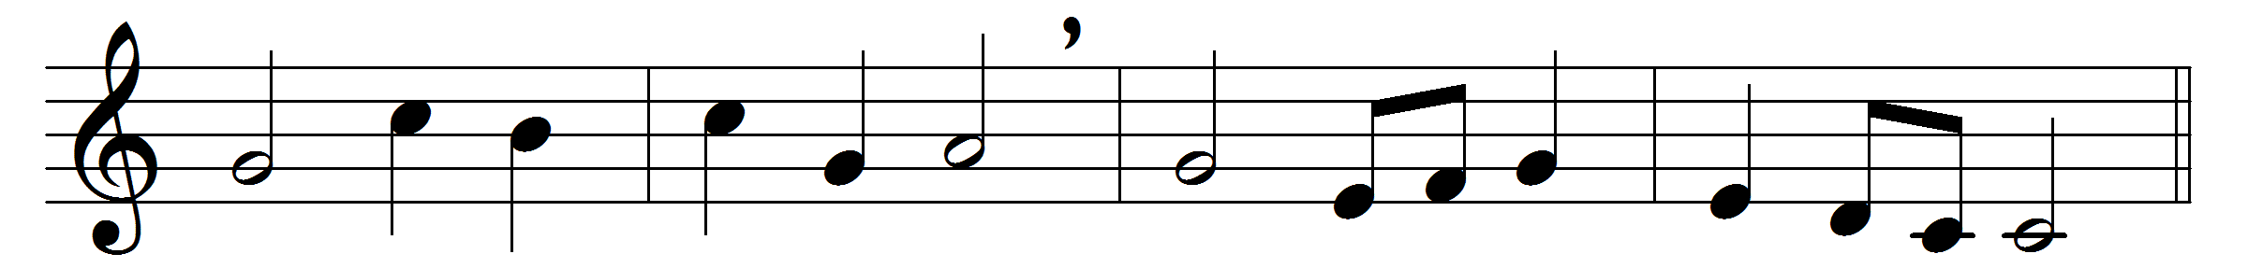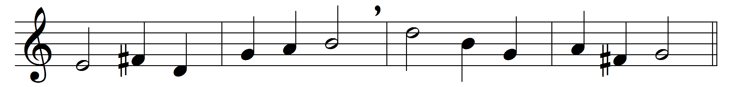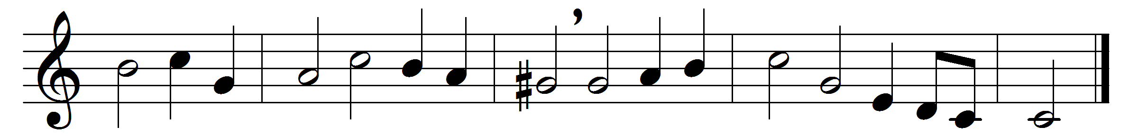

Lord of the worlds above
how pleasant and how fair
the dwellings of thy love,
thy earthly temples, are!
To thine abode
my heart aspires,
with warm desires
to see my God.
O happy souls that pray
where God appoints to hear!
O happy men that pay
their constant service there!
They praise thee still;
and happy they
that love the way
to Zion’s hill.
They go from strength to strength
through this dark vale of tears,
till each arrives at length,
till each in heaven appears:
O glorious seat!
when God our King
shall thither bring
our willing feet.

Words: Isaac Watts (1674-1748)
Music: William Croft (1678-1727)

