Great Shepherd of thy people, hear AMNS 164 Melody: Oswald’s Tree C.M.
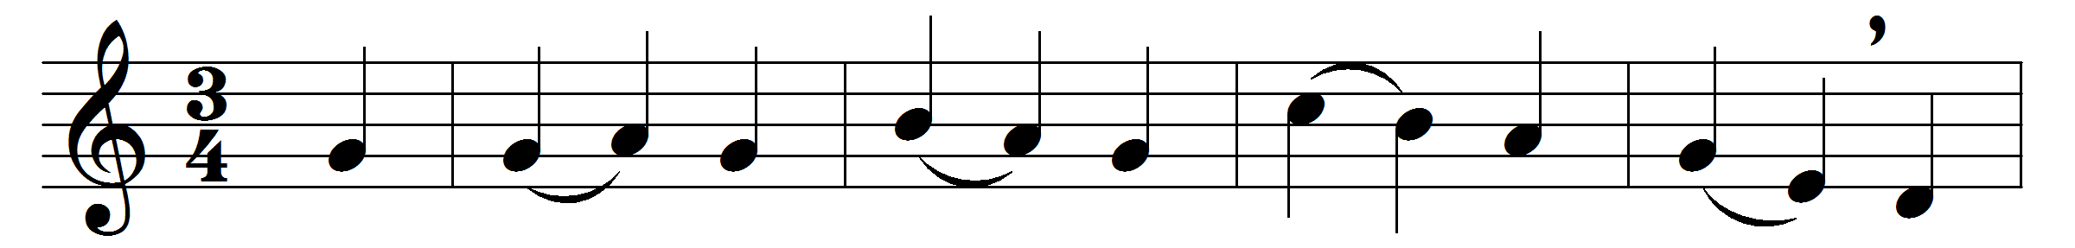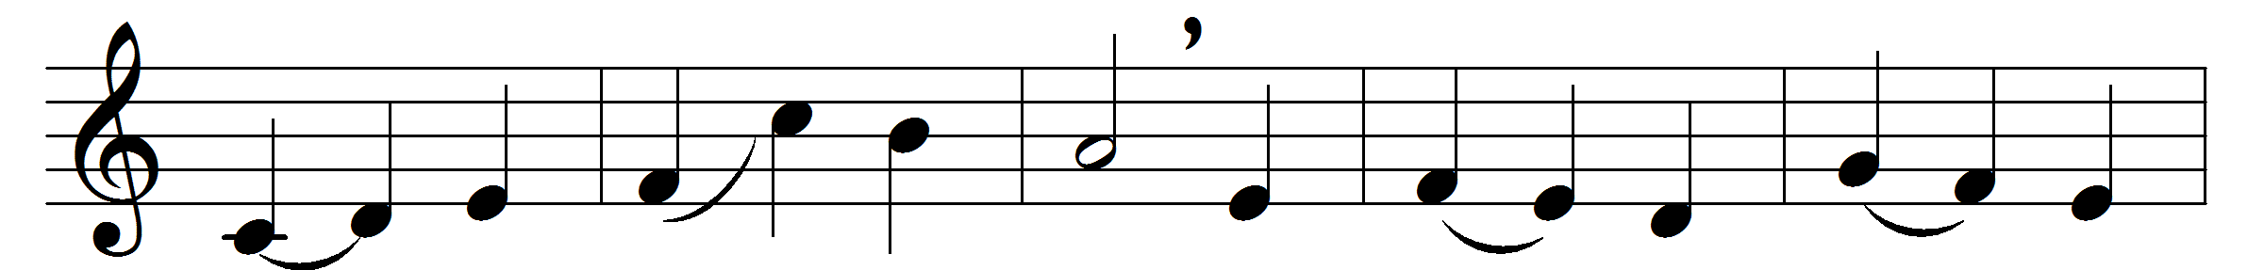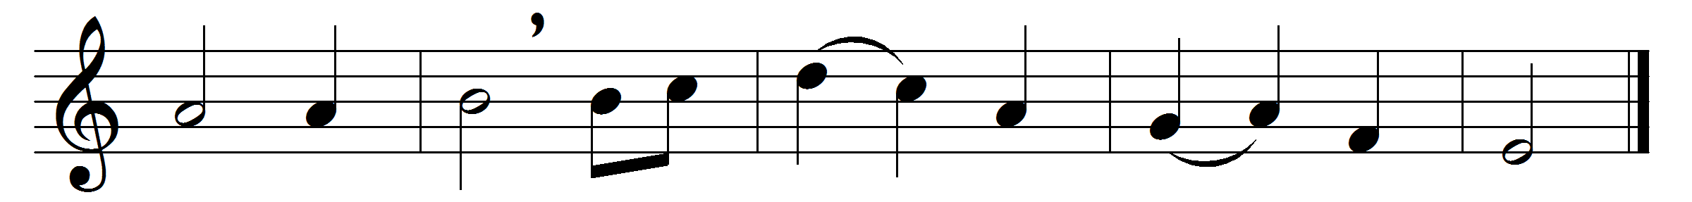

Great Shepherd of thy people, hear,
thy presence now display;
as thou hast given a place for prayer,
so give us hearts to pray.

Within these walls let holy peace
and love and concord dwell;
here give the troubled conscience ease,
the wounded spirit heal.

May we in faith receive thy word,
in faith present our prayers,
and in the presence of our Lord
unbosom all our cares.

The hearing ear, the seeing eye,
the contrite heart, bestow;
and shine upon us from on high,
that we in grace may grow.

Words: John Newton (1725-1807)
Music: Henry Walford Davies (1869-1941)

