Christ is our corner-stone AMNS 161 Melody: Harewood 6. 6. 6. 6. 4. 4. 4. 4.
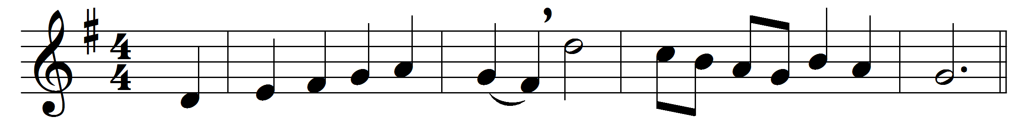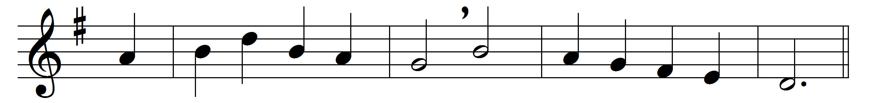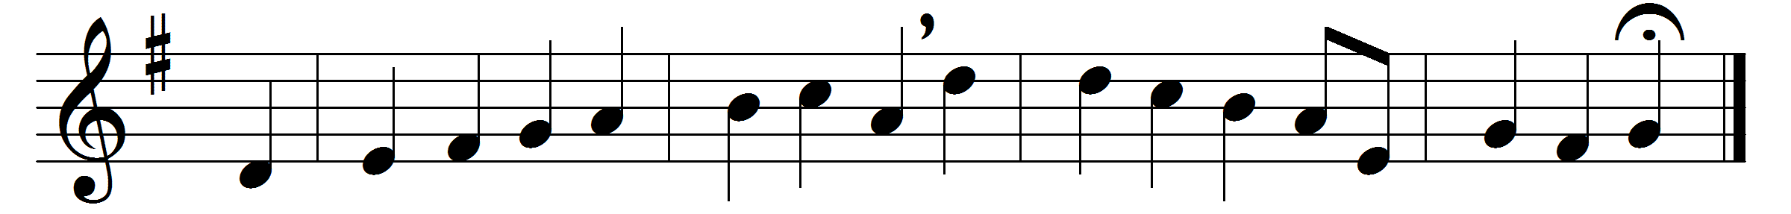

Christ is our corner-stone,
on him alone we build;
with his true saints alone
the courts of heaven are filled:
on his great love
our hopes we place
of present grace
and joys above.

O then with hymns of praise
these hallowed courts shall ring;
our voices we will raise
the Three in One to sing;
and thus proclaim
in joyful song,
both loud and long,
that glorious name.

Here, gracious God, do thou
for evermore draw nigh;
accept each faithful vow,
and mark each suppliant sigh;
in copious shower
on all who pray
each holy day
thy blessings pour.

Here may we gain from heaven
the grace which we implore;
and may that grace, once given,
be with us evermore,
until that day
when all the blest
to endless rest
are called away.

Words: Latin, before 9th century, translated by John Chandler (1806-1876)
Music: Samuel Sebastian Wesley (1810-1876)

