O King enthroned on high AMNS 158 Melody: Temple 6. 6. 8. 4.
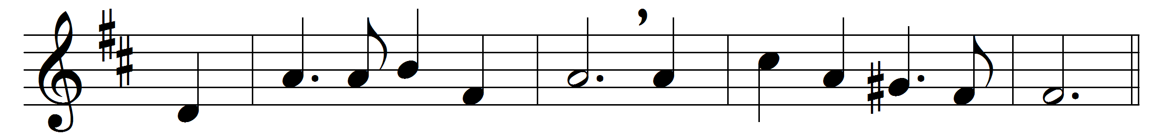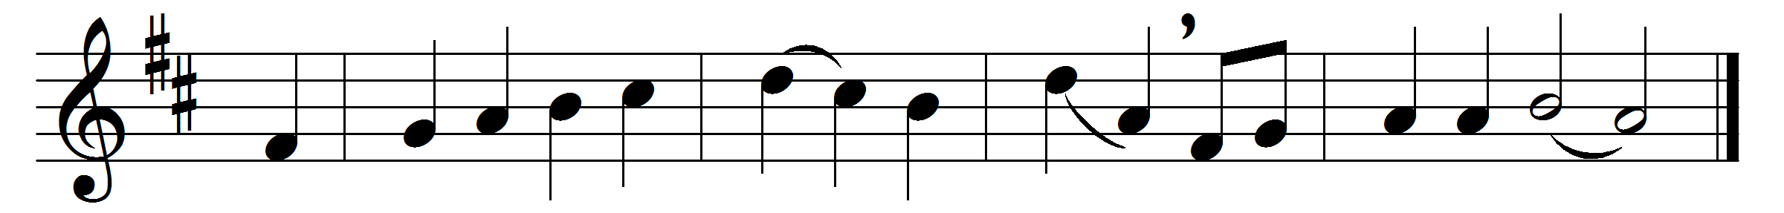

O King enthroned on high,
thou Comforter divine,
blest Spirit of all truth, be nigh
and make us thine.
Thou art the source of life,
thou art our treasure-store;
give us thy peace, and end our strife
for evermore.
Descend, O heavenly Dove,
abide with us alway;
and in the fulness of thy love
cleanse us, we pray.

Words: Greek, c. 8th century, translated by John Brownlie (1857-1925)
Music: Henry Walford Davies (1869-1941)

