Breathe on me, Breath of God AMNS 157 Melody: Wirksworth (Aylesbury) S.M.
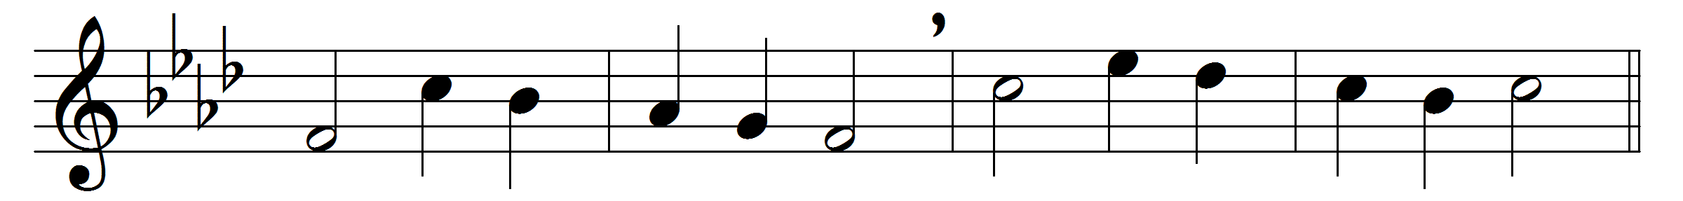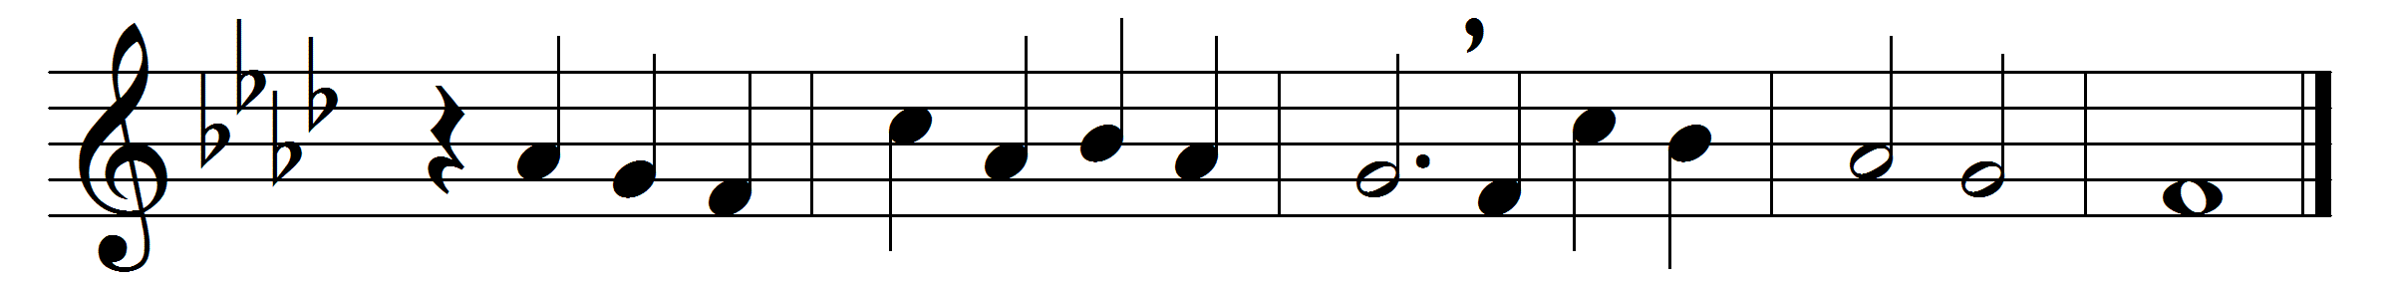

Breathe on me, Breath of God,
fill me with life anew,
that I may love what thou dost love,
and do what thou wouldst do.
Breathe on me, Breath of God,
until my heart is pure;
until with thee I will one will,
to do and to endure.
Breathe on me, Breath of God,
till I am wholly thine;
until this earthly part of me
glows with thy fire divine.
Breathe on me, Breath of God:
so shall I never die,
but live with thee the perfect life
of thine eternity.

Words: Edwin Hatch (1835-1889)
Music: Adapted from John Chetham (Psalms, 1718)

