Come, gracious Spirit, heavenly Dove AMNS 153 Melody: Hawkhurst L.M.
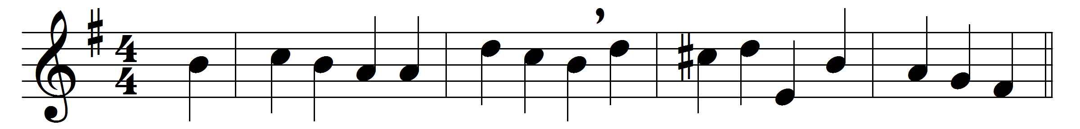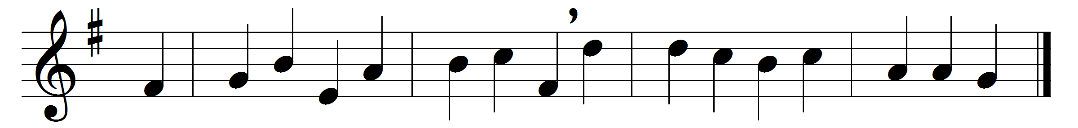

Come, gracious Spirit, heavenly Dove,
with light and comfort from above;
be thou our guardian, thou our guide,
o’er every thought and step preside.
The light of truth to us display,
and make us know and choose thy way;
plant holy fear in every heart,
that we from God may ne’er depart.
Lead us to Christ, the living Way,
nor let us from his pastures stray;
lead us to holiness, the road
that we must take to dwell with God.
Lead us to heaven, that we may share
fulness of joy for ever there;
lead us to God, our final rest,
to be with him for ever blest.

Words: Simon Browne (1680-1732) and others
Music: Henry John Gauntlett (1805-1876)

